Storage Side table
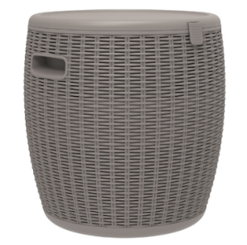
Content:
- 1piece lid.
- 1piece bucket.

Use & Care:
- This product doesn’t require Assembly.
- For indoor and outdoor use.
- Handle heavy parts with care.
- Never tilt the product use.
- Do not stand or climb onto the product.
- Do not sit or lean onto the arms/rims of this product.
- This product should only be used on firm, level ground. Ensure the product is always placed on level ground.
- If there is any water leakage, don’t use it.
- To clean the product, it can simply be wiped down by hand with a damp sponge and a weak solution of soap and water. Never use scourers, abrasives or chemical cleaner.
- We would recommend lifting the products to move the items instead of dragging them which may cause some damage to either the product or the area in which you choose to use them.
- This will keep ice for 10-12 hours under 20-25 degrees and 6-8 hours under 30-35 degrees.
- Maximum weight load is 110lbs

Usage Guidance:
1) Make sure the plug is tightly in the bottom hole;
2) Load ice into the bucket;
3) Place the wines, beers or any other products intended to be cooled;
4) Close the lid for longer cooling time;
5) The lid can be hooked on the bucket rim.

Note: This item is only a temporary cooling bucket, it cannot be used as a powered cooler or refrigerator to store the goods.
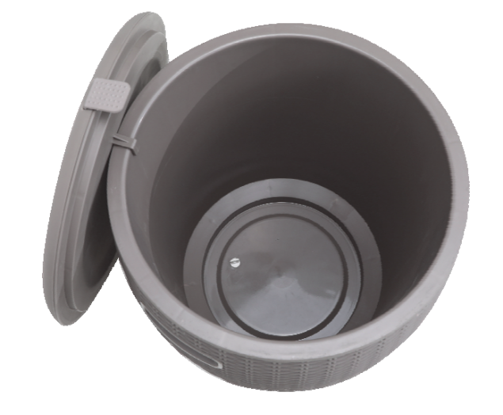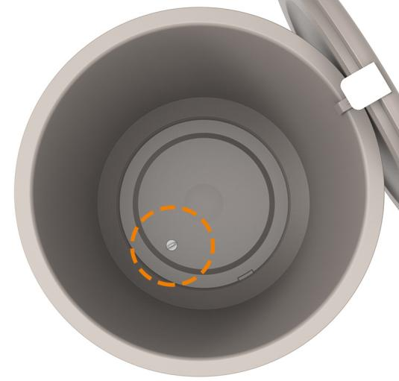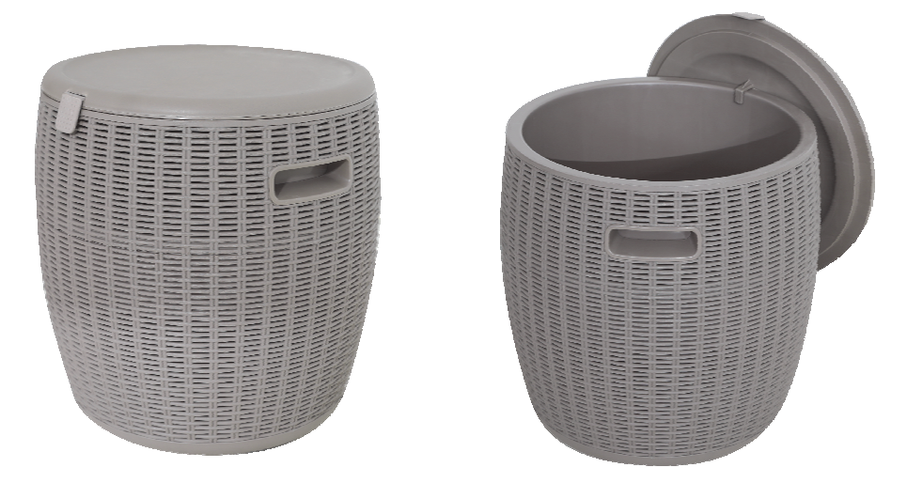

Please retain this information for future reference

Made in China.

