New combo heat press machine
Digital，double-display，self-clocking
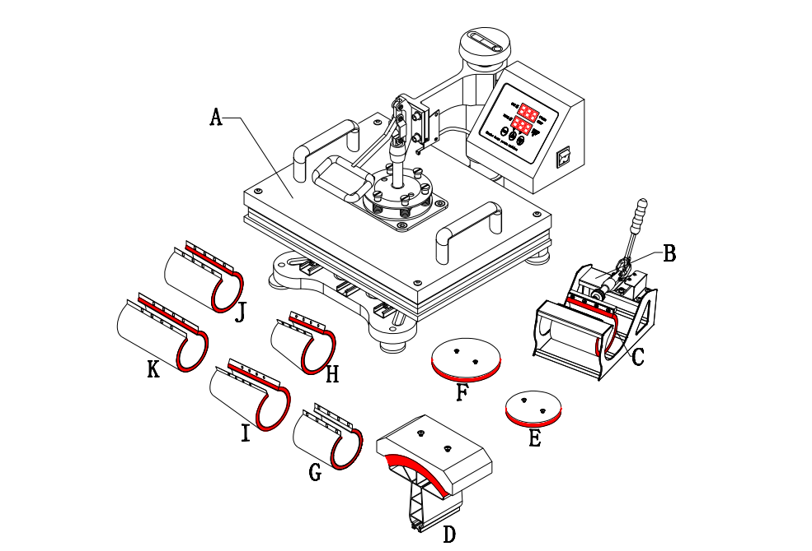
Instruction

A : Platen Press (telfon-coated)
B : Mug Press Machine
C : Mug Press（12*23.5cm）( 11oz )
D : Hat/Cap press：5.5"x 3" （14*8cm）
E : Plate Press #1 5" max diameter （12.5cm）
F : Plate Press #2 6" max diameter （15.5cm）
G : Mug Press 12*19cm
H : Mug Press 12OZ
I : Mug Press 17OZ
J : Mug Press 15*19cm
K :Mug Press 13.5*23.5cm

Respectable users，thanks for purchasing T18digital multi-functional heat press machine.It is the unique combo heat press with perfect slideway in the world ，which have got the patented technology protection.
This machine adopts microprocessor program control ，featuring high precision inparameter memory and control and unique touch button control panel in China.The advanced design philosophy and independent control unit structure provides convenience for combination and upgrading of machines and after-sale service.
With slideway ,it is faster and more convenient to replace thermal transfer components. Some important components use imported material ,so it is more stable and durable. In addition ,the design of the machine is very nice and luxurious,and machine takes very small room ,so it is good for the selling and operating of the shops.
Ⅰ.Features
- Brand new slideway design ,so it is easy and fast to replace parts.
- Add automatic count down button and self-clocking alarm.
- Digital double control the controller uses microprocessor program ,parameter memory ,so the control accuracy is much higher .
- For the controlling heating chip ,it uses the new degree Celsius,so the power is more stable ,and the circuit board will not break down when the voltage is not steady .
- Heating thermocouple:adopting new generation “K”updated version heating thermocouple .with double lines merged ,it is safer and not easily broken down.(The glass tube is adopted for traditional ordinary machinery to pack thermistor .once in case of unstable voltage, it will be easily broken down ,burn out or crashed into pieces due to the uneven pressure!)
- The aluminum plates are all upgraded and thickened ,the quality becomes more secure and the phenomena of uneven base board and carrying capacity are avoided .The upgrading of quality ,material and technology further guarantees the quality !
- Can be lifted ,lowered and rotated by 360 degrees and convenient to retrieve articles and transfer of alien articles.
- Adding one heat-resisting foaming silicon on the baseboard ,which can stand 400 centigrade degrees and will not deform.
Ⅱ.Technical parameters
Specification:

Main Heating plate size ：29*38CM /1000W 38*38CM/1200W

Packing Size ：51.5*51.5*44.5CM 59.5*51.5*44.5CM

Power input: 110v 220v

Temperature range ： (0 - 200 Centigrade)
Timer control: 0 - 999 seconds

4in15in1

Four Elements: Five Elements:
Main Heating plate(telfon-coated) Main Heating plate (telfon-coated)
Hat/Cap pad printing area： Hat/Cap pad printing area：
5.5"x 3" （14*8cm） 5.5"x 3" （14*8cm）
Mug Press（12*23.5cm）( 11oz ) Mug Press（12*23.5cm）( 11oz )
Plate Press #1 5" max diameter （12.5cm） Plate Press #1 5" max diameter （12.5cm）
Plate Press #2 6" max diameter （15.5cm）
6in18in1

Six elements： Eight elements：
Main Heating plate(telfon-coated) Main Heating plate(telfon-coated)
Hat/Cap pad printing area： Hat/Cap pad printing area：
5.5"x 3" （14*8cm） 5.5"x 3" （14*8cm）
Plate Press #1 5" max diameter （12.5cm） Plate Press #1 5" max diameter （12.5cm）
Plate Press #2 6" max diameter （15.5cm） Plate Press #2 6" max diameter （15.5cm）
Mug Press 12*23.5cm Mug Press 12*23.5cm
Mug Press 12*19cm Mug Press 12*19cm
Mug Press 12OZ
10in1 Mug Press 17OZ

TEN Elements：
Main Heating plate(telfon-coated)
Hat/Cap pad printing area：5.5"x 3" （14*8cm）
Plate Press #1 5" max diameter （12.5cm） Plate Press #2 6" max diameter （15.5cm）
Mug Press 12*23.5cmMug Press 12*19cm Mug Press 12OZMug Press 17OZMug Press 15*19cm Mug Press 13.5*23.5cm

Ⅲ.Operation guide
- Controller introduction：
OUT : heating WORK： count down introduction light
SET：function setting ▲ ：increasing ▼ ：decreasing /count down by manual
PV/SV
TIMES
PV/SV
TEMP
:LED temperature display :LED temperature display
- Parameter setting guide （Celsius showing）:
A、Temperature setting
Press “SET”,the upper display will showing “SP”,and the lower of display will showing the temperature of last setting .then enter into temperature setting option ,press ▲ or▼(increase or decrease )to set the needed temperature .After setting well ,please press “SET”,the upper display will show “S”to go on the next step for time setting .
B、Time setting
Press “SET”again , LED will showing “S”,then enter into the time setting .press ▲ or▼(increase or decrease )to set the needed time .(Normally the time is 180 seconds for mugs and 15-20 seconds for T-shirt printing）
C、Celsius and Fahrenheit setting
Press “SET”again ，the controller display will showing C-F ，the bottom of display will showing “C”or “F”，please press ▲ or▼ to adjust C（Celsius）or F（Fahrenheit） according to your demands.
- Advanced parameters setting :
Long press “SET “ button for 5 seconds ，and then enter into advanced setting
（Attention ！！！Please don‘t use this advanced setting if you are not professional）
A、Temperature adjust ：long press “SET “button for 5 seconds ，and press “SET ” one more time ，the upper of display will showing “SC”，then enter into temperature adjust ，press ▲ to decrease ，or press▼to increase the temperature .
When the actual platen measurement temperature not in accordance with the display temperature ,please set again as following:
Press ▲ to decrease the temperature when the actual measurement temperature is lower the display temperature.
Press ▼ to increase the temperature when the actual measurement temperature is higher the display temperature.
B、Overshoot setting :long press “SET”button for 5 seconds ,and press “SET”2 times again ,the upper display will showing P,and the bottom of display showing “1”,press ▲ or▼ to adjust ,when turn on the machine ,the temperature will raising up and over the setting temperature ,and calm down to the set temperature ,press ▲ button to increase “1”,when turn on the machine ,the temperature is raising very slow and cannot reach on the set temperature ,press ▼ button to decrease “1” .the specific data of increase or decrease will be going well after several trying .
C、Constant temperature setting : long press “SET “for 5 seconds，and press “SET”3 times again ,the upper display will showing “I”,the bottom of display showing “25”,press ▲ or▼ to adjust .when power on the machine ,the temperature raising up and reached the setting temperature,but the display showing not accurate ,always higher or lower the actual temperature ,please use this function to adjust . When the display showing temperature is higher the actual temperature ,press ▲ button to adjust “25”become higher; when the display showing temperature is lower the setting ,press ▼ to adjust “25” become smaller ,until the display showing correctly .
D、Heating period : long press “SET”button for 5 seconds ,and press “SET”4 times again ,the upper display will showing “K”,and the bottom display will shoeing “8” ,press ▲ or▼ to adjust .
The principle of this function is that when the temperature raising up and reached the setting temperature ,the temperature controller will control the relay (SSR) ,every 8 seconds will power on and then power off after 8 seconds in order to control the constant temperature heating. If the platen heating up and reached the temperature ,and the temperature not stable, always higher and lower ,it says 8 seconds frequency is too low ,press ▼ to adjust till it bu stable .please take note that if the temperature is stable ,please do not use this function, since if use too much ,the life will short of the relay .
Ⅳ.Replacement of accessories
The counterdie of the heat press equipment is slide rail design .it is only necessary to plug it out and replace accessories easily and conveniently.
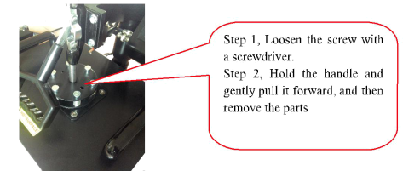
- Parts replacement instruction

2.Adjustable mat
Uneven work surface,adjust the height and direction of the mat will be ok
A、Adjust the height of the mat roughly ,in order to achieve the basic flat
B、Adjust the direction of the mat finely ,in order to achieve the completely flat .
installation for each heating accessories ：
Platen press (for t-shirt):plug out other heating pad ,and put this flat into the sliding rails and fix it .
Plate press parts installation :maintain the bottom flat-panel ,and push “E” or “F”(Plate Press )into the hole and fixed with a screwdriver.
Mug press parts installation : put foaming rubber pad fixed in mag shelves (push the long screws into the both side holes of the steel mug shelves directly ,without disassembly of the screws ).Mug press parts installation : the mug press you ordered (C、G、H、I、J or K)fixed on the Mug press machine ”B”, the cup pad (directly to the cup mat sheet steel on both sides of the long screw on both ends of the Mug press machine “B”directly into the corresponding hole location can, without the mounting screws), put the mug press mat thermocouple plug and mug press machine countdown on switch plug to control box outlet can printing the corresponding size mugs.
Cap press parts installation: push one part along the slide rails ,and push the other part into the hole and fixed with a screwdriver.Push the below part of the “D” (Hat/Cap press) i along the slide rails, the above part(Hat/Cap pad printing mat) into the hole and fixed with a screwdriver.
C、Adjust pressure
Adjust the right pressure before printing or after rep;ace different accessories.
Turn the pressure regulator to adjust appropriate pressure,then turn the back side to lock the screw cap .
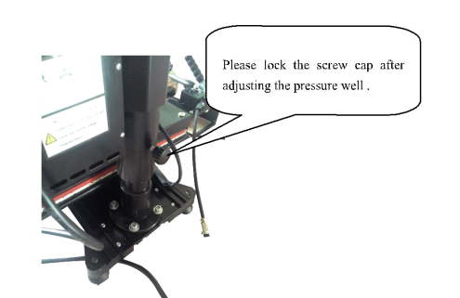

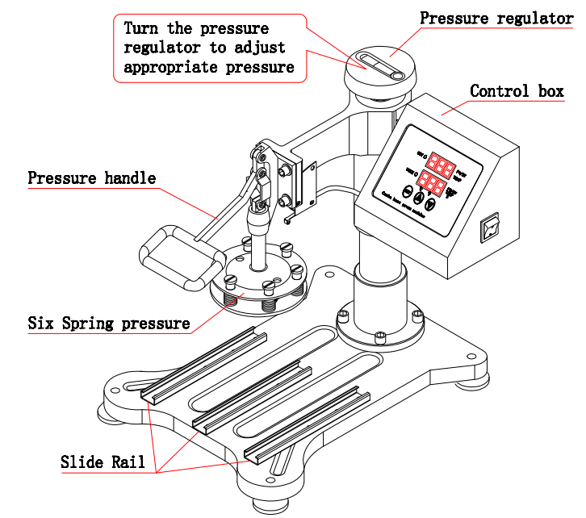

D、Install and uninstall control box &connected to heating plate and limit switch.
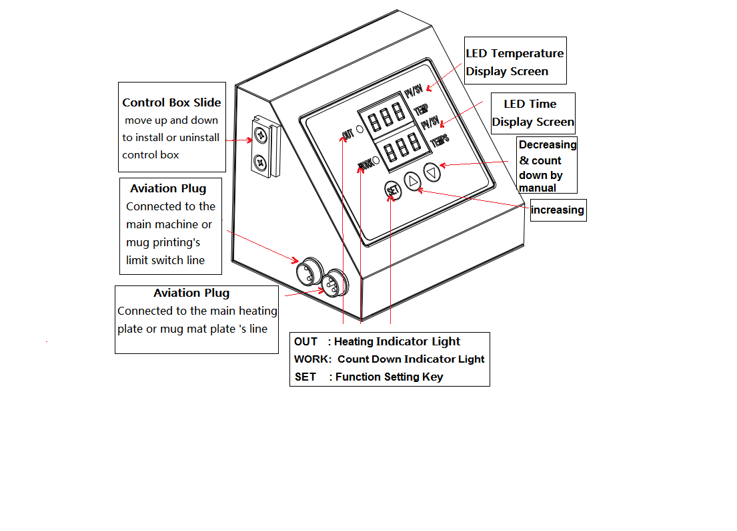

Ⅴ.Kindly prompts:
To print and make individualized DIY products, it is also necessary for you to prepare the following equipments and materials.
1. Ink jet printer/ six colors printer (For example: Epson R-230 / R270 / R290 / T50)
2. CISS (Continuous ink supply system)
Different models of Ink jet Printer will need different CISS.
3. Sublimation ink / Heat transfer ink;
4. High-temperature resistant tape;
5. Sublimation paper / Heat transfer paper (for Ceramic and fabric)
6. Paper cutter
7. Press mug / cup and plate: Normal mug and plate will can not use for press, Only sublimation mug and plate can be use.
Ⅵ.WANRRANTY SERVICE REGULATIONS
All machine can enjoy 3 months free warranty since the sale date , please contact us or the dealers ,if have any quality problems .
More than warranty period we still provide long-term technical support and maintenance instruction ,only charge the accessories costs.
In accepting the warranty service ,please provide all of information as follow:
You can send us those information ,through the scans or express way .
ADDRESS:
REPAIR DATE:
REPAIR FAULT:
REPAIR REASON:
FAULT HANDING
CUSTOMER NAME &ADDRESS:
EMAIL:
PRODUCTS MODEL:
PURCHASE DATE:

