Ash Vacuum Cleaner Operation Manual

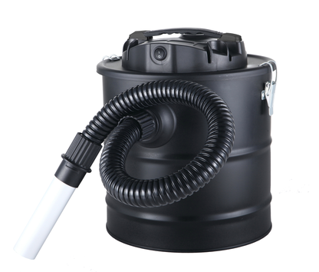

EP22711

The appliance is dry pick-up use only
Attention: Please read this manual before installing and usage.
The important instruction:
• Check whether or not the local power supply main matches the appliance electric rating printed on the label before operation.
• When the appliance is not in operation, please remove plug from supply mains.
• The plug must be removed from the socket-outlet before cleaning or maintaining the appliance
• Don't remove the plug by pulling the power cord.
• Do not leave the appliance alone when the appliance is in work.
• This appliance can be used by children aged from 8 years and above and persons with reduced physical, sensory or mental capabilities or lack of experience and knowledge if they have been given supervision or instruction concerning use of the appliance in a safe way and understand the hazards involved. Children shall not play with the appliance. Cleaning and user maintenance shall not be made by children without supervision
• Don't press and roll the power cord by heavy objects.
• If the supply cord is damaged, it must be replaced by the manufacturer or its service agent or a similarly qualified person in order to avoid a hazard.
• Don't vacuum the objects as follows: liquid, inflammable and explosive dangerous material, corrosive material and burning ash, match, and cigarette.
• Do not use the appliance to vacuum the dust harmful to health.
• Keep the appliance in dry environment.
• Don't touch the live parts in appliance.
• Only to repair the appliance by the manufacturer or its authorized service agent.
• Do not use appliance for other than intended use.
• Pay more attention when cleaning the stairs.
• Use the accessories and spare parts only supplied by the manufacturer or its authorized service agent.
• When use the appliance to vacuum fireplace ash, No ashes with a temperature more than 40°C shall be vacuumed, No ashes and other objects that the fire is not completely extinguished shall be vacuumed.
• Do not use the appliance if the filter is not installed! Do not use other filters except the ones (fire prevention filter) attached to the appliance by manufacturer.
• For cold ash only, “Cold Ash” is ash cooled down for a sufficient time without any pockets of embers inside. This can be confirmed by scouring the ash for pockets of embers by using metal tools before using the ash vacuum cleaner. Cold ash does not emit any recognizable heat.
• Substance to be vacuumed - cold ashes from fireplaces, wood/coal stoves, ashtrays, grills.
• Empty and clean vacuum cleaner before and after vacuuming to avoid the collection of materials that could pose a fire hazard in the vacuum cleaner.
• Do not use for the separation of health-hazardous dusts (dust classes M)
• Do not vacuum soot
• Vacuum only ashes from admissible fuels
• Do not vacuum any hot, burning or glowing objects
• Do not vacuum any objects that are hotter than > 40 °C
• Do not vacuum any flammable substances

1.Handle 2.Cover 3.Aluminium tube 4.Air inlet 5.Soft hose 6.Power switch 7.Tank 8.Fire prevention HEPA filter
9.Metal Mesh Cover

6
1
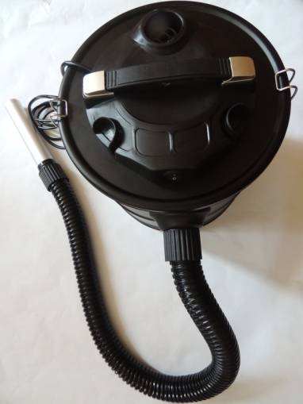
2
7
3

4
5

9
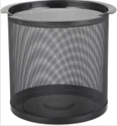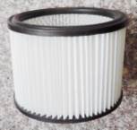
8

Fig. A1
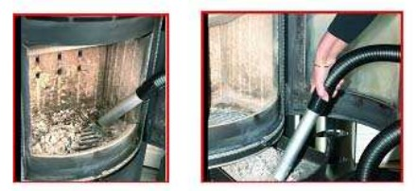

Fig. A2

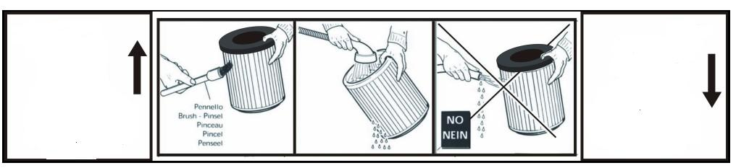
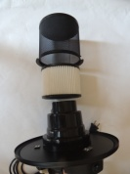

Fig. A3

The function of the parts:
• Aluminum pipe: Used to vacuum ash in the fireplace (Fig. A2)
• Power switch: Control the appliance to work or stop working
I. 1) Installation of the vacuum cleaner• Take out the appliance and accessories from the packing box, check the accessories and whether the appliance enclosure is well-found or not. (Fig. A1) • Loose the clasp, and take the head part from the container. • Attach the filter set to the bottom of head part. • Put the head part on the container and use the clasp to make it fixed. • Insert the aluminum pipe into the soft tube, and another end of soft tube is inserted into air inlet. (Fig. A1)
2) Installation of Blowing function uses
• As shown in the picture, put ① into the air outlet④ and tighten it to
①
④
the left
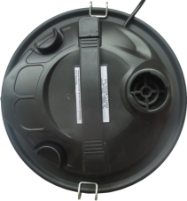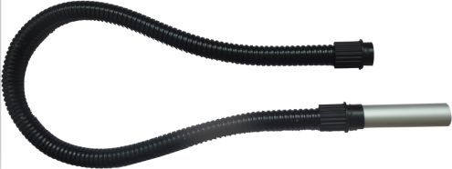
Short

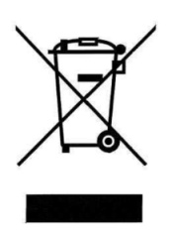
③
②

- Put aluminum tube③ into ②
Longer

II. Vacuum ash
• Only use the fire prevention filter.
• When the container is full or it feels difficult to vacuum more dust, the filter needs to be taken out and cleaned.
• While vacuum the fireplace ash, the ash temperature must be below 40°C. Do not vacuum the ashes that fire is not extinguished! (Fig. A2)

III. After the usage (Fig. A3)
• Press the switch to turn off vacuum cleaner.
• Pull out plug.
• Roll up the power cable.
• Disassemble the soft tube from the appliance.
• Take the head part from the appliance.
• Empty the dust container and wash it.
• Use rag to dry the container.
• Take out the filter, clean and wash it carefully, and dry it in air before installed on vacuum cleaner. (Fig. A3)

IV. Maintenance (Fig. A3)
• The container and outer shell of head part need to be cleaned frequently.
• The dirty container should wash with the clear water clearly.
• The filter should wash with the clear water clearly.
• If the appliance working unsatisfactory, it is usually resulted from the jam of soft tube or conjunction of pipes or accessories. In that case, please clean the parts concerned.

V. Correct Disposal of this product
This marking indicates that this product should not be disposed with other household wastes throughout the EU. To prevent possible harm to the environment or human health from uncontrolled waste disposal, recycle it responsibly to promote the sustainable reuse of material resources. To return your used device, please use the return and collection systems or contact the retailer where the product was purchased. They can take this product for environmental safe recycling.

VI. Warranty Information
The manufacturer provides warranty in accordance with the legislation of the customer's own country of residence, with a minimum of 1 year (Germany: 2 years), starting from the date on which the appliance is sold to the end user.
The warranty only covers defects in material or workmanship.
The repairs under warranty may only be carried out by an authorized service centre. When making a claim under the warranty, the original bill of purchase (with purchase date) must be submitted.
The warranty will not apply in cases of:
- Normal wear and tear - Incorrect use, e.g. overloading of the appliance, use of non-approved accessories - Use of force, damage caused by external influences - Damage caused by non-observance of the user manual, e.g. connection to an unsuitable mains supply or non-compliance with the installation instructions - Partially or completely dismantled appliances

Tech-date
Model | Power | Voltage | Frequency
EP22711 | 1000W | 110-120V | 60HZ

