Warm&Cool
Mist Humidifier

Model：EP23066

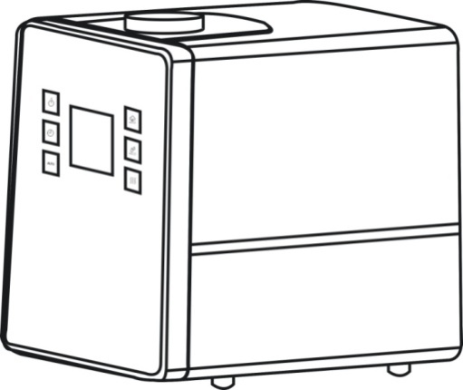

MANUAL INSTRUCTIONS

WARNING!!
THIS HUMIDIFIER IS NOTA TOY
DO NOT LET CHILDRENPLAY WITH IT!!

PLEASE READ THE INSTRUCTIONS TO ENSURE
SAFE USE OF THIS HUMIDIFER

WARNING!
READ THESE INSTRUCTIONS.
Failure to follow the instructions may result in fire, electric shock and/or serious injury.

- This humidifier is intended only for indoor use.
- Use only clean water. Do not use hot water.
- It is recommended to use filtered or distilled water.
- Make sure that cap of tank is tightened firmly.
- The mist direction should be aimed away from walls, electric appliances, furniture and children.
- Do not force the Mist Nozzle to a certain angle. To adjust the angle, resettle it.
- Place the humidifier on a flat, smooth, level surface.
- Do not plug and unplug humidifier with wet hands.
- Use only a 120Volt ，60Hz outlet.
- Unplug the humidifier when moving or cleaning it.
- Unplug the humidifier when not in use.
- Do not attempt to empty, fill, and tilt the humidifier while it is working.
- This appliance is not intended for use by persons (including children) with reduced physical, sensory or mental capabilities, or lack of experience and knowledge, unless they have been given supervision or instruction concerning use of the appliances by a person responsible for their safety.
- Children should be supervised to ensure that they do not play with the appliance.
- If the power cord is damaged, it must be replaced by the manufacturer or a qualified service engineer to avoid any risks to safety.
- Care should be taken when using the appliance due to the emission of hot water vapour.
1
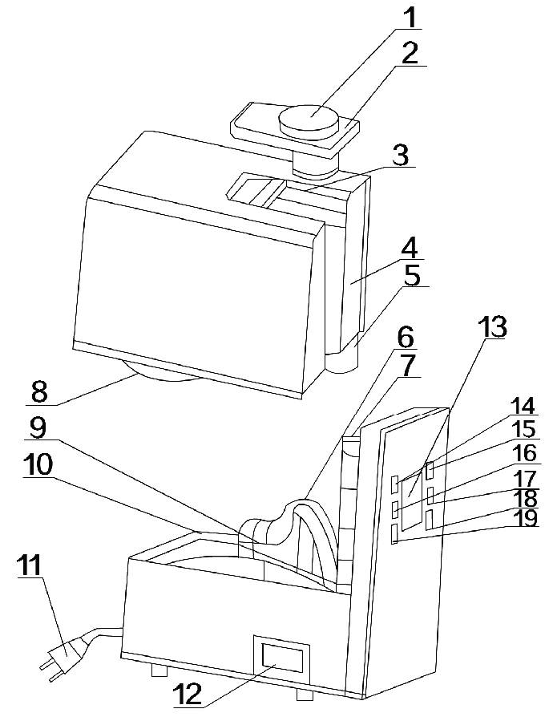
Structure
- Fog month
- Handle cover
- Handle
- Water tank
- Water lever Switch
- Guide channel
- Guide ducts
- Schrew of the tank
- Nebulizer
- Fumigating machine
- Cable
- Oil Box
- Display screen
- ON/OFF switch
- Fog setting
- Timing
- Humidity setting
- Hot fogs
- Automotive

Functions
- Huge humidity capability thus it can meet large space
- Hot cool fog selections which can meet different requirements
- It can humidify the whole room balanced
- Automatically keep in room in a fixed humidity percentage
- It can make your environment smelling and relaxed with aromatherapy
- It will turn off automatically once the water tank is taken off which makes it reliable and safe

2
Operation

Instructions:
1)The working environment of a humidifier: Temperature is aroud5-45㎡ and relative humidity is lower than 80%
2)Water must be lower than 40℃ ( It is advised to pour purified water into your tank)
3) The water tank should be washed if it did not be used for a long time

Functions of keys:
On/Off Switch: When you plug the cable, the beeper will di and then your humidifier will automatically go to standby status: Once you pressed the button then your humidifier will show working status at the display screen and will shut itself off when you repress the button to turn off you humidifier.
Automaticity Button: If you pressed the button automaticity, your humidifiers adjust the humidity itself.
Fog adjusting button: The button can adjust the fog from low to middle as well as high level
Humidity: You can set your desired humidity by this button. Once the humidity is reached, your humidifier will stop working.
Heater: The button can adjust the temperature from low to middle as well as high level

Timing: You can set time to humidify. Every hour can be a min setting unit for timing. You can set 1-12 different timing for your humidifier.

3
Steps to operate:
1, Remove mist lid, turn water tank upside down & unscrew water tank cap and fill water tank with cool water
2, Screw water tank cap back onto water tank. Turn the water tank over and place on water basin, making sure if fits perfectly. Put the mist lid back at the same time
3, Plug the power cord into a wall socket and turn on the unit by using the On/Off switch
4, If you want its aromatherapy, you can then make it work by the below steps:
A, Withdraw the aromatherapy box (Picture 1 ) b, Pour liquid of aromatherapy to it until the cotton wet (Picture 2) c, Put the aromatherapy box back and turn on the humidifier (Picture 3) d, If you no longer need aromatherapy, you then need to take off the aromatherapy cotton and wash it and then put it back.
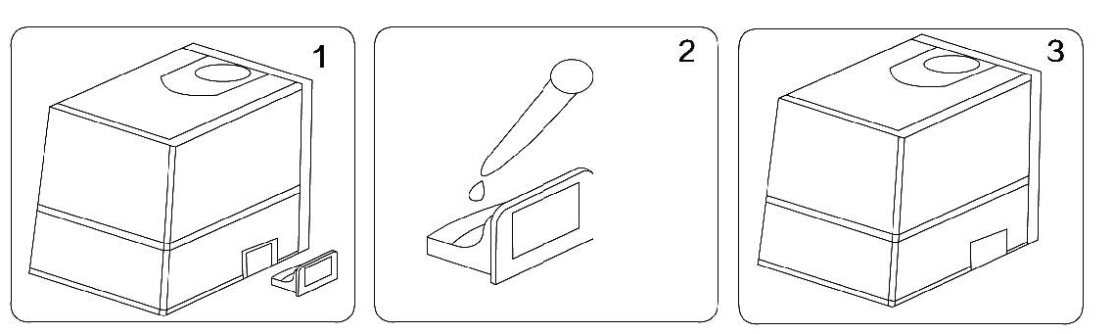

Maintenance

Due to its tough water of some area, you’d better wash its inner and outside of your humidifier around every 2 weeks with calcium oxalate

Steps to clean your humidifier
1, Take off the guide channel by the below order
a, First of all you’d better revolve the guide ducts
b, Take off the guide channel

4
c, You can then wash the tank as the picture 3 below and then install them back
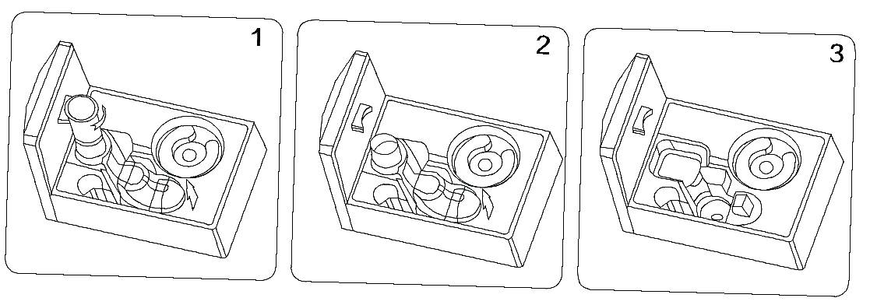

2, You can pour 30ml liquid of calcium oxalate, and soak for about 30 minutes
3, Wash it with brush until the dirt gone
4, Rush it with clean water twice

STORING
1.Before storing, the humidifier must be cleaned and drained.
2.When storing the unit, make sure that all parts are dry.
3.Do not close the water tank cap too tight. Leave it loose, so it should not stick to the gasket.
4.Do not put anything on top of the unit during storage, to prevent any damage to it.
5.Save the box and store the unit in the box.

5
TROUBLE SHOOTING
DO NOT ATTEMPT TO REPAIR
THE HUMIDIFIER YOURSELF
Problem | Reasons | Solution
No wind nor fog out | No power | Plug it to the power
 | Do not turn on the on/off switch | Turn it on
 | No water in the tank | Pour water to the tank
 | The water is not enough in the tank | Pour more water to it
Fog has strange smell | New machine | Lay the tank at the cool place for 12 hours
 | Dirty water in it | Clean the tank and pour clarified water into it
Abnormal noise | The tank did not put back exactly | Place the tank back again
 | The water is not enough in the tank | Pour more water to in
 | The desk is not plain | Put in to a plain desk
Fog come out around | There’s a gap between the cover & tank | Soak the fog month for a while

SPECIFICATIONS
Model | EP23066
Voltage | 120V 60Hz
Power | 280W
Capacity | 6.0L

6

