Cool Mist Humidifier

Model：EP23067

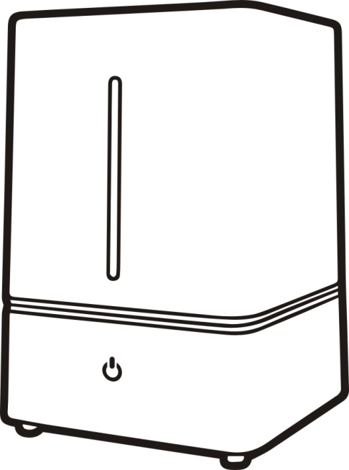

MANUAL INSTRUCTIONS

WARNING!!
THIS HUMIDIFIER IS NOTA TOY
DO NOT LET CHILDRENPLAY WITH IT!!

PLEASE READ THE INSTRUCTIONS TO ENSURE
SAFE USE OF THIS HUMIDIFER

WARNING!
READ THESE INSTRUCTIONS.
Failure to follow the instructions may result in fire, electric shock and/or serious injury.

- This humidifier is intended only for indoor use.
- Use only clean water. Do not use hot water.
- It is recommended to use filtered or distilled water.
- Make sure that cap of tank is tightened firmly.
- The mist direction should be aimed away from walls, electric appliances, furniture and children.
- Do not force the Mist Nozzle to a certain angle. To adjust the angle, resettle it.
- Place the humidifier on a flat, smooth, level surface.
- Do not plug and unplug humidifier with wet hands.
- Use only a 220-240 Volt ，50-60Hz outlet.
- Unplug the humidifier when moving or cleaning it.
- Unplug the humidifier when not in use.
- Do not attempt to empty, fill, and tilt the humidifier while it is working.
- This appliance is not intended for use by persons (including children) with reduced physical, sensory or mental capabilities, or lack of experience and knowledge, unless they have been given supervision or instruction concerning use of the appliances by a person responsible for their safety.
- Children should be supervised to ensure that they do not play with the appliance.
- If the power cord is damaged, it must be replaced by the manufacturer or a qualified service engineer to avoid any risks to safety.
- Care should be taken when using the appliance due to the emission of hot water vapour.
1
Instructions
Magnetic Floating
Radiator Cap
Plug
Tact Switch

Working Producer
- Working Environment: Temperature: 5℃-40℃,humidity≤80%RH.

- Water should be under 40℃ when cleaning up. ( Pure water is recommended).

2.1.Take off the water tank and put the water tank upside down.

2.2.As shown in picture 1, please unscrew the tank cover counterclockwise, refill the water, then tighten the radiator cap clockwise, smoothly put in on the base.( do not directly refill the water from the mist outlet).
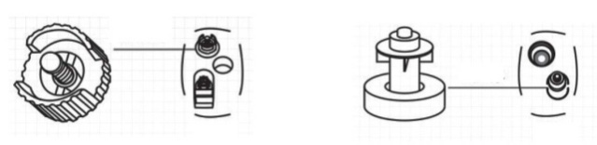

Picture 1 picture 2

2.3.The water in the tank will hold up the magnetic float, as shown in picture 2 below. LED light will flicker if there’s no water in the tank.

2.4. The mist outlet will be installed on the top of the water tank correctly and do not spray the nozzle on other household appliances.

2.5. Press the Tact Switch means power on at working low-grade state, press twice working at higer mist state, press third means shut down, as shown in picture 3.

2
2.6. The magnetic float will go down and the switch light will be flashing indicating lacking of water. Please turn off the power and repeat the first step to refill water.

2.7. When humidifier is in working state, long press switch for 1.5 seconds, night lights will be turned on; press switch for 1.5 seconds again, night lights will be turned off.

2.8. A fragrance box and a filtering net will be included as shown in picture 4.
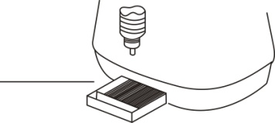

Picture 4

STORING
- Before storing, the humidifier must be cleaned and drained.

- When storing the unit, make sure that all parts are dry.

- Do not close the water tank cap too tight. Leave it loose, so it should not stick to the gasket.

- Do not put anything on top of the unit during storage, to prevent any damage to it.

5.Save the box and store the unit in the box.

3
TROUBLE SHOOTING
DO NOT ATTEMPT TO REPAIR
THE HUMIDIFIER YOURSELF
Problem | Reasons | Solution
No wind nor fog out | No power | Plug it to the power
 | Do not turn on the on/off switch | Turn it on
 | No water in the tank | Pour water to the tank
 | The water is not enough in the tank | Pour more water to it
Fog has strange smell | New machine | Lay the tank at the cool place for 12 hours
 | Dirty water in it | Clean the tank and pour clarified water into it
Abnormal noise | The tank did not put back exactly | Place the tank back again
 | The water is not enough in the tank | Pour more water to in
 | The desk is not plain | Put in to a plain desk
Fog come out around | There’s a gap between the cover & tank | Soak the fog month for a while

SPECIFICATIONS
Model | EP23067
Voltage | 120V 60Hz
Power | 23W
Capacity | 4.0L

4

