INSTRUCTION MANUAL HANDLE HELD BLENDER
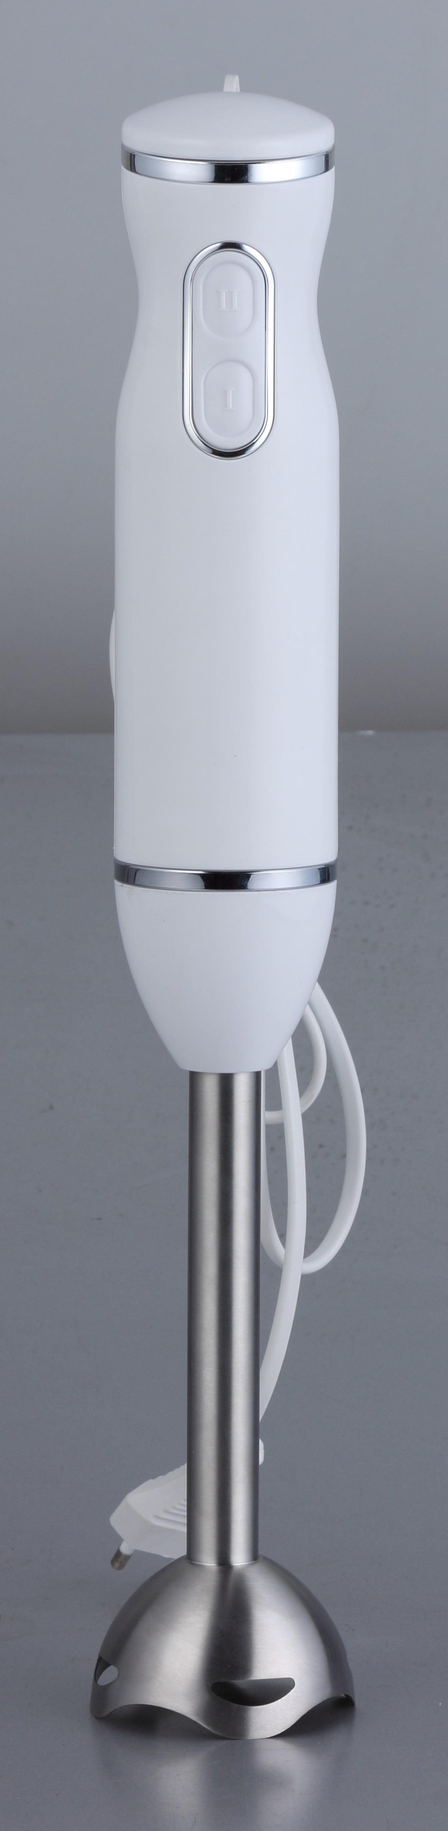
EP23147US: 120V, 60Hz, 300W;

IMPORTANT SAFETY RECOMMENDATION
- Read the instructions carefully before using your appliances for the first time.

- Make sure the rated voltage in your local place is conformity to the rating plate on the unit.
- Never leave the appliance with in reach of children without supervision. The use of this appliance by young children or by disabled person must always be supervised.
- Do not use outdoors. The appliance is household use only.
- Unplug your appliance when you finish using it or clean it.
- Do not use the appliance if it has damaged. You should contact an approved service center.
- If the power cable or plug are damaged, do not use the appliance. To avoid any risk, these must be replaced by an approved service center.
- Do not allow long hair, scarves etc. to hang down over blender stick or whisk when they are in operation.
- Never put the appliance close to heat source.
- Please the note: The blades of the appliance are sharp. Handle the blades with care.
- Before using your appliance first time, clean the various accessories carefully. Do not immerse motor unit in water or any liquid.
- Save the instruction for your future reference.
- The appliance is not intended for use by persons (including children) with reduced physical, sensory or mental capabilities, or lack of experienced and knowledge, unless they have been given by a person responsible for their safety.
- Children should be supervised to ensure that they do not play with the appliance.
- If the supply cod is damaged, it must be replaced by the manufacturer, its service agent or similarly qualified persons in order to avoid a hazard.
- Switch off and disconnect from the supply the appliance before changing accessories or approaching parts, which move in use.
- Always disconnect the blender from the supply if it is left unattended and before assembling, disassembling or cleaning.
- Do not allow children to use the blender without supervision.

HOW TO USE STICK BLENDER
- Twist the stick blender onto the unit at anti-clockwise until it is locked.
- Plug in the appliance.
- The beaker must be not more than 2/3 full to prevent over flowing.
- Always use the stick blender to blend ingredients together with water or other liquid.
- Do not use the stick blender to blend hard foods only, such as coffee bean, ice cubes, sugar, cereals, chocolate etc.
- Two speeds set for your different blending various ingredients.
- Do not operate the stick blander more than 20 seconds at one time, allow a few minutes rest for next use.
- When you take out the stick from the motor unit, make sure of it unplugged.
- Its blade is sharp, handle it with care to avoid any hurt of you.
- The max. capacity of container is 700ml, the quantity of ingredients consist of 1 parts soaked carrots and 4 parts water.

HOW TO CLEANING
- Unplug the appliance.
- Clean the body of the appliance with a damp cloth. Do not immerse the motor unit in any liquid.
- The chopper gear box may be rinsed under the tap, but do not immerse it in water.
- Clean the blades and accessories immediately after using, and avoid bacterial growth. Take care of the blades because they are too sharp!!

HOW TO STORAGE
For easily storage the appliance, locate the accessories holder on the chopper gear box. Turn the motor unit on
the holder, then put the whisk, blender stick on the accessories holder separately.
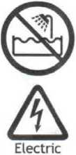
CAUTION: Use extreme care when handing the Double Blade Knife.
Do not touch the Blades with your fingers. The Blades are very sharp and can cause injury if touched.

TECHNICAL DATA
EP23147US: 120V, 60Hz, 300W
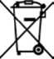
Correct Disposal of this product
This marking indicates that this product should not be disposed with other household wastes throughout the EU. To prevent possible harm to the environment or human health from uncontrolled waste disposal, recycle it responsibly to promote the sustainable reuse of material resources. To return your used device, please use the return and collection systems or contact the retailer where the product was purchased. They can take this product for environmental safe recycling.

