

Bread Maker
Instruction Manual
Item No.: EP23609
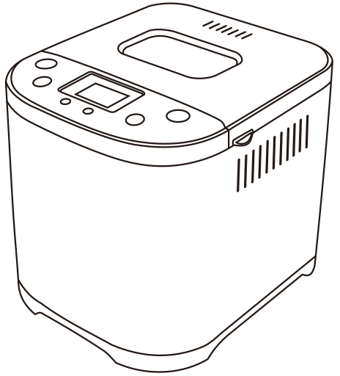

Read all instructions before using and save it for future reference
CONTENTS :

IMPORTANT SAFEGUARDS --------------------03-04
PRODUCT FEATURES -------------------------04-05 QUICK-IDEALS-TO-MAKE-BREADS -------------05-06
INTRODUCTION OF CONTROL PANEL -----------06-07
OPERATING GUIDE ---------------------------07-11
SPECIFIC FUNCTIONS DESCRIPTION ------------11-13
RECIPES RECOMMENDED ----------------------13-17
CLEANING AND MAINTENANCE --------------------18
TECHNICAL SPECIFICATION ----------------------18
PROBLEM SOLUTION -------------------------18-19

IMPORTANT SAFEGUARDS
When using the electrical appliance, basic precautions should always be followed including the following:
Read all instructions.
This appliance can be used by children aged from 8 years and above and persons with
reduced physical, sensory or mental capabilities or lack of experience and knowledge if they have been given supervision or instruction concerning use of the appliance in a safe way and understand the hazards involved. Children shall not play with the appliance. Cleaning and user maintenance shall not be made by children unless they are older than 8 and supervised. Close supervision is necessary when any appliance is used by or near children.
Keep the appliance and its cord out of reach of children less than 8 year.
Do not operate any appliance with a damaged cord or plug or after the appliance malfunctions or has been damaged in any manner. Return appliance to the nearest authorized service facility for examination, repair or electrical or mechanical adjustment. If the supply cord is damaged, it must be replaced by the manufacturer, its service agent
or similarly qualified persons in order to avoid a hazard.
CAUTION: Hot surfaces. Do not touch hot surfaces. Use handles or knobs. Do not let cord hang over edge of table or counter or touch hot surface.
The appliances are not intended to be operated by means of an external timer or separate remote-control system.
Clean surfaces in contact with food.
Before use, check that the voltage of wall outlet corresponds to the one shown on the rating plate.
8. To protect against electric shock do not immerse cord, plugs, or housing in water or other liquid.
9. Unplug from outlet when not in use and before cleaning. Allow to cool before putting on or taking off parts.
10. Do not place on or near a hot gas or electric burner, or in a heated oven.
11. Extreme caution must be used when moving an appliance containing hot oil or other hot liquids.
12. Do not touch any moving or spinning parts of the machine when baking.
13. Never switch on the appliance without properly placed bread pan filled ingredients.
14. Never beat the bread pan on the top or edge to remove the pan, this may damage the bread pan.
15. Always attach plug to appliance first, then plug cord into the wall outlet. To disconnect, turn any control to OFF, then remove plug from wall outlet.
16. The appliance is not intended to be operated by means of an external timer or separate remote-control system.
17. Do not operate the unit without bread pan placed in the chamber to avoid damaging the appliance.
18. The use of attachments not recommended by the manufacturer may cause fire, electric shock or injury.
19.Do not use it outdoors.
20.Do not use appliance for other than intended use.
SAVE THESE INSTRUCTIONS
HOUSEHOLD USE ONLY
- A short power-supply cord should be used to reduce the risk resulting from becoming entangled in or tripping over a longer cord.
- Longer extension cords are available and may be used if care is exercised in their use.
- If a longer extension cord is used:
1)The marked electrical rating of the cord set or extension cord should be at least as great as the electrical rating of the appliance; and
2)The cord should be arranged so that it will not drape over the countertop or table top where it can be pulled on by children or tripped over unintentionally.
If the appliance is of the grounded type, the extension cord should be a grounding-type 3-wire cord.

PRODUCT FEATURES
1

2
3
4
- LCD display
- viewing window
- Air Hole
- Steel lid
- Control panel
- Steel housing
5
- Plastic bottom
- Bread bowl
- Knead paddle
6
- Measuring cup
- Measuring spoon
- Hook

7
8
9
10
11
12
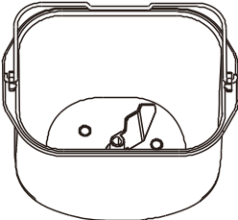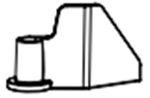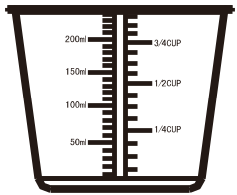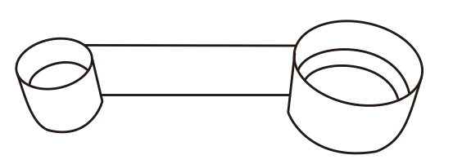

Explanation on Measuring Cup
Cup of liquid. (Please see the right graphic)
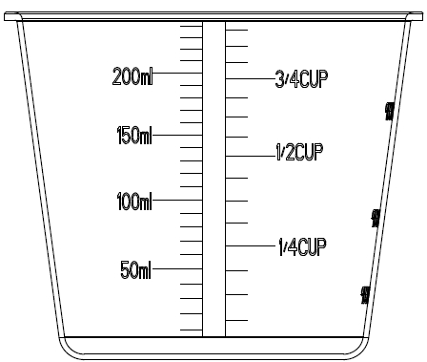
- When you take some liquid with transparent
cup and try to measure desirable amount,
place measuring cup on the flat table at your
eyes level. If need to add egg or milk,
you would have to mix them into water before
reading scale.
- Measure solid powder ingredient: hold
desirable solid powder with this transparent
measuring cup, shaking cup lightly in order
to flatten the surface of powder, and then read correct scale. Please don’t shake cup for long or sharply, otherwise the powder might descend to the scale lower than requested amount.
Tips: one cup of flour’s weight approximated 160g

Measuring Spoon： small spoon and big spoon, used for measuring material

Hook：used for taking the Stirring Rod out from bread.

QUICK-IDEALS-TO-MAKE-BREADS
Made Soft Bread at 1.5LB and Medium Color：
1. Clean Bread Barrel, Stirring Rod, Measuring Cup and Measuring Spoon.

2. Align the oblate hole at stirring rod to the corresponding position of revolving axle in bread barrel and fix in appropriate position.

3. As recommended Recipe Book’s “Soft Bread” -1.5LB please add material by order. Be sure to add yeast powder above flour and not allow yeast powder to touch water.

4. Put bread barrel into the container and fix it into position, covering the lid.

5. After plugging bread baker to outlet screen displays Defaulted Menu immediately: 1.5LB/Medium Color/ Soft Bread

6．Press “Start/Stop/Pause” with a buzzer sound, indicator light flashed, and bread baker begins to knead.

7. The bread is done as soon as the countdown is over. At this time, program auto-starts “Keep Warm”.

8. Pressing “Start/Stop/Pause” for 3 second followed by giving a buzzer sound, “Keep Warm” is stopped.

9. After bread is done, please wear glove to lift bread barrel and take it out, turning barrel upside down to take out bread.

Tips
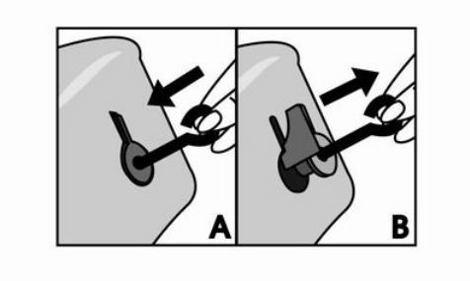
It may happen the stirring rod remains
stuck in the bread when it is turned out .
In this case, use the hook accessory
as follows.
- insert the hook in the axis of the
stirring rod(A).
- pull gently to release the stirring rod(B).

Attention: the above bread-making approach is the easiest, no need to use “Menu”, “Loaf” and “Color”.

INTRODUCTION OF CONTROL PANEL
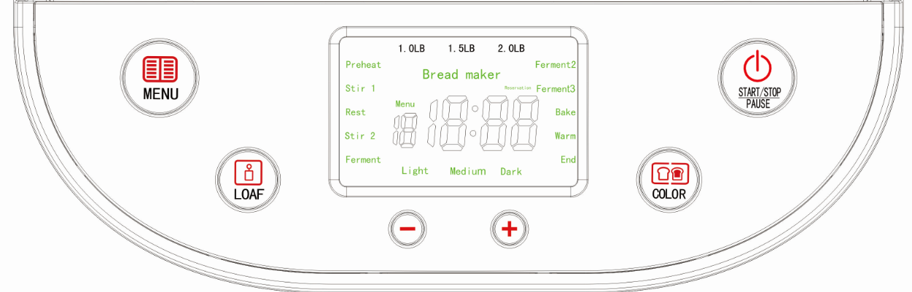
1. “Menu”：
When select one from the menus 1-15 displayed in Control Panel (see the right graphic), LCD indicator will show the corresponding setting:
1—Soft Bread 2—Sweet Bread 3—Natural sourdough
4—French 5—Whole-Wheat 6—Quick
7—Sugar-free 8—Multigrain 9—Milky Loaf
10—Cake 11—Raw Dough 12—Leaven Dough
13—Gluten free 14—Bake 15—Yogurt

2.”LOAF”： In setting status, pick one of 1.0LB/1.5LB/2.0LB as bread weight. Except for 1 to 9 “loaf” can’t be adjusted. And three weight 1.0LB/1.5LB/2.0LB choice.

3. “COLOR”：Select bread color by pressing Light/Medium/Dark one by one in circle for Whole Wheat Bread, French Bread , . Select bread color by pressing Light/Medium/Dark one by one in circle for sweet bread .When select one color, the upper will display the corresponding mark.

4.“START/STOP/PAUSE”：Press this button to start or stop the working of bread maker, giving a buzzer sound. When bread baker begins to work, for avoiding exceptional contact or collision, this performance will start “Exceptional Stop” as protection performance. When press this button for 1second until hear a prompt sound “Buzz”, the unit stops working immediately.
NOTE: Within one second short press is “Pause” , the program stops the countdown, the machine all the action at status of “Pause”, you can add some ingredients, etc., press again to quit “pause”, all programs continue the original action. “Stop” Press 3 seconds or more is required.
5.“+”： In setting status, each pressing this button will add 1,5 or 10minutes delay. If press this button without releasing, the program would rapidly add the time of delay up to the maximum time of delay. At this moment program would return to the original minimum time of delay and continue to move like this in circle.
6.“-” ： In setting status, each pressing this button will reduce 1,5 or 10minutes delay. If press this button without releasing, the program would rapidly reduce the time of delay up to the minimum time of delay. At this moment program would return to the original maximum time of delay and continue to move like this in circle.

7. Working status includes: Reservation（if you need）—Preheat—Knead1--Rest—Knead2— Ferment1,2,3 --Bake—Keep Warm—Complete

OPERATING GUIDE
Please be careful before use：
★ Check wire cord, socket and fuse box in order; Rating Load is higher than 3A.
★ Bread Maker must be grounded in safe. Earth Wire and Zero Line must be separated, preventing them from twisting in each other over three-plug connector.

Operation Instruction on making bread:
1． Take out bread barrel from the inside of container and put stirring rod into barrel.
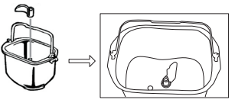
Then place the half-round hole of stirring rod into the right position at the revolving axle.
2． Add the appropriate amount of water, egg and flour into barrel, and finally add yeast powder.
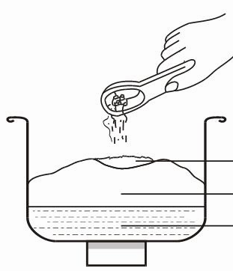

Insure yeast powder to be added above flour and don’t mix yeast powder with water, sugar and salt, otherwise the activation of yeast will be weaken or can’t workable.
Yeast Powder

Flour or other Stuff
Mixture of Water, Oil, Sugar and Salt

3. Put the barrel holding the mixture of material into container and close the upper cover.

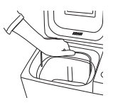
Align barrel to the inside container.
①If you found a obstruct with barrel during pressing down, you could lift barrel again and turn the axle at the bottom of barrel to the another angle.
②After placing barrel into container, then rotate the barrel clockwise, barrel is fixed.

4． Plug bread maker to outlet followed by a buzzer sound and indicator displays the following:
The default value after starting unit is 1.5LB/Medium Color/ soft bread
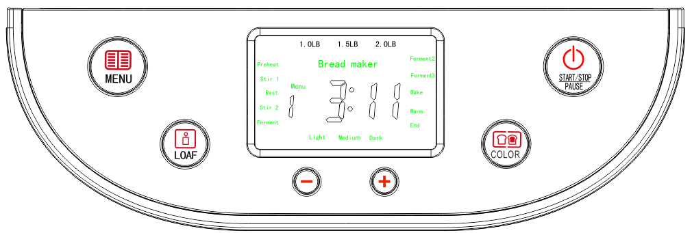

5． Select Desirable Bread Recipe
Press , The number will be moving in circle from 1-15 .1-9 are bread recipes.

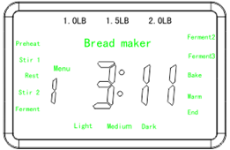
6. Select Desirable Bread Color and Loaf

Press

Press 

Indicating Mark

7. Set “Reserve” Time
If you want to make bread right now, please skip current step.
Press

Press
Time

8. Start The Unit and Begin to Make Bread
Press “Start/Stop/Pause”, begin to Count Down .

- After starting Bread Maker the unit begins to stir flour. For avoiding the splashing of flour, the program can auto-set interval stirring at the first 2minutes. After 2minutes, auto-switches to continuous stirring.
- After setting “Reserve”, “:” at LCD indicator begins to flash and the unit is started. When Countdown begins, flour stirring begins too.
- When “Whole Wheat ” is in working, the unit will not stir flour at once even not setting “Reserve”. The first 30minutes are for dip in whole wheat flour and the second 30minutes begins stirring flour. The flashing of “:” at LCD indicates the unit is working.

FOR THE FIRST USE
The appliance may emit a little smoke and a characteristic smell when you turn it on for the first time. This is normal and will soon stop. Make sure the appliance has sufficient ventilation.
1. Please check whether all parts and accessories are complete and free of damage.
2. Clean all the parts according to the section“CLEANING AND MAINTENANCE”.
3. Set the bread maker on BAKE mode and bake empty for about 10 minutes. Then let it cool down and clean all the detached parts again.
4. Dry all parts thoroughly and assemble them, the appliance is ready for using.

9. The Finishing of Bread-making
When countdown is up to 0:00, the buzzer sound will be given to notify that bread is done.
1. Keep Warm Refer to page 12 for “Keep Warm”
2. Non-heat ①press “Start/Stop/Pause” for 1second
remove plug from outlet

10. Take Out Bread
Because bread is very hot, please wear glove and shake bread lightly before taking it out.

“Cake” Operation Instruction
The operations on cake are similar to how to make bread. As the ingredients for cake making mentioned in Recipe Book, you can select “cake” and start it.
Press “Menu” ,select program 15, it’s make the cake , default time is 1 hour and 33minutes.

“Raw dough” Operation Instruction
The operations on Kneading Dough are similar to how to make bread. As the ingredients for kneading mentioned in Recipe Book (no salt, sugar and milk powder) you can select “raw dough” and start it.
Press “Menu” ,select program 11 , it’s work the “Raw Dough”, default time is 23 minutes.
Can not select Color and Weight. As “Knead” is finished, a buzzer sound is given.

“Leaven dough” Operation Instruction
You can make fermented dough. As the ingredients for kneading mentioned in Recipe Book (no salt, sugar and milk powder) you can select “Leaven dough” and start it.
Press “Menu” ,select program 12, it’s work the“Leaven dough”, default time is 1 hour and 24 minutes.
Can not select Color and Loaf. As “Knead” is finished, a buzzer sound is given.

“Bake” Operation Instruction
This is a performance with powerful practical use. Once you grasped how to make bread, you can just use “Leaven Dough” to control the time of stirring and of leavening needed and even make or invent many new kind breads you loved with “Bake”.
Press “Menu” ,select program 14, it’s work the “Bake” ,default Time is 10 minutes, can be adjusted from 5minutes to 1 hour 30 minutes

“Yogurt” Operation Instruction
This is a performance with powerful practical use. You can rise the dough or making yogurt, rum.
Press “Menu”, select program 15. It is work the “Yogurt”. The Default Time is 8 hours,
It can adjust the time between 5 hours and 13 hours

SPECIFIC FUNCTIONS DESCRIPTION
Reserve Function
The purpose of this performance is for your having the fresh bread on next morning.
For example, now is at 8:30 in the evening and wish to have ready-made bread in the morning 7:00.
- Compute Reserving Time: it should be 10hours and 30minutes from the evening 8:30 to the next morning 7:00.
- Set Reserving Time
Press the “+” and “-” , set the time ,After setting the time, press the "Start" button.
Note: The time displayed on the screen is set to 10 hours and 30 minutes, this display time includes the time to make bread, at 7:00 you can have the bread.
Reservation function Tips:
1) when use reservation function, do not put eggs, as eggs will go bad too long, it will affect the taste of bread.
2) covered the yeast under flour , in order to maintain the activity of the yeast.

Buzzer Sound
⑴ A buzzer sound is given as electricity is connected.
⑵ A buzzer sound is given as Loaf, Color, Menu or Time Setup is pressed.
⑶A buzzer sound is given as switch “Start/Stop”.
⑷ In kneading process the buzzer sound is given continuously to remind you of adding material.
⑸A buzzer sound is given as the operation is finished.
⑹ The intermittent buzzer sound is given as “Keep Warm” is closed down.

Memory Function to Occasional Electricity Disconnection
⑴ This unit holds a 15minutes Memory-keeping to occasional electricity disconnection: after starting bread maker, if an occasional electricity-disconnection happened and its duration is not more than 15minutes, re-connecting electricity would make bread maker continue to work. After re-connecting electricity, the time of working could be changed and not equal to the original time set before:
Actual Working Time = Time of Disconnecting Electricity + Original Working Time Set Before
⑵ If the duration of electricity disconnection is more than 15minutes, the bread maker can’t continue before work time .

Keep Warm
For making your use easier this bread maker is supported with heat preservation performance. When bread or other snacks are finished and don’t be taken out in time, “Keep Warm” can keep them fresh at certain temperature.
- After bread is done the program auto-enters “Keep Warm” with flashing “:”. The maximum time for preserving is 1hour. “Keep Warm” will be closed down until the buzzer sound is given in an intermittent way.
- Or directly press Start/Stop/Pause for 3 seconds until a buzzer sound is given and then “Keep Warm” closes down.

RECIPES RECOMMENDED
1. Soft
Material | 1LB | 1.5LB | 2LB
Water | 160ml | 240ml | 290ml
Butter | 2Big Spoon | 2Big Spoon | 3Big Spoons
Table Salt | 1/2Small Spoon | 1/2Small Spoon | 1Small Spoons
Sugar | 1Big Spoon | 2Big Spoon | 3Big Spoon
Milk Powder | 2Big Spoons | 3Big Spoons | 5Big Spoons
Flour | 300g | 400g | 475g
Yeast Powder | 1Small Spoon | 1Small Spoon | 1Small Spoon
2. Sweet
Material | 1LB | 1.5LB | 2LB
Water | 160ml | 240ml | 310ml
Butter | 2Big Spoons | 2Big Spoons | 3Big Spoons
Table Salt | 1/2 Small Spoon | 1/2Small Spoon | 1/2 Small Spoons
Sugar | 4Big Spoons | 6Big Spoons | 6Big Spoons
Milk Powder | 2Big Spoons | 3Big Spoons | 4Big Spoons
Flour | 300g | 400g | 500g
Yeast Powder | 1 Small Spoon | 1Small Spoon | 1Small Spoon

3. Natural curing
Material | 1LB | 1.5LB | 2LB
Water | 160ml | 200ml | 240ml
Sugar | 1Big Spoon | 1Big Spoon | 2Big Spoon
Milk Powder | 2Big Spoon | 3Big Spoon | 4Big Spoon
Butter | 1Big Spoon | 1Big Spoons | 2Big Spoons
Table Salt | 1/2Small Spoon | 3/4Small Spoons | 1Small Spoons
Flour | 275g | 350g | 400g
Yeast Powder | 1/3Small Spoon | 1/3Small Spoons | 1/3Small Spoons

4. French
Material | 1LB | 1.5LB | 2LB
Water | 200ml | 260ml | 320ml
Butter | 2Big Spoon | 2Big Spoons | 3Big Spoons
Table Salt | 1/2Small Spoon | 1/2Small Spoons | 1/2Small Spoons
Milk Powder | 2Big Spoon | 3Big Spoon | 4Big Spoon
Flour | 300g | 400g | 500g
Yeast Powder | 1Small Spoon | 1Small Spoons | 1+1/4Small Spoons

5. Whole Wheat
Material | 1LB | 1.5LB | 2LB
Water | 210ml | 280ml | 340ml
Butter | 2Big Spoon | 2Big Spoons | 3Big Spoons
Table Salt | 1/2Small Spoon | 1Small Spoon | 1+1/2 Small Spoons
Flour | 150g | 200g | 250g
Whole Wheat Flour | 150g | 200g | 250g
Sugar | 2Big Spoon | 3Big Spoons | 4Big Spoons
Yeast Powder | 1Small Spoon | 1+1/4Small Spoons | 1+1/2Small Spoons

6．Quick
Material | 1LB | 1.5LB | 2LB
Water(104~122°F) | 180ml | 240ml | 300ml
Butter | 2Big Spoon | 2Big Spoons | 3Big Spoons
Table Salt | 1/2Small Spoon | 1/2Small Spoon | 1/2Small Spoon
Flour | 280g | 375g | 450g
Sugar | 1Big Spoon | 2Big Spoons | 3Big Spoons
Milk Powder | 2Big Spoons | 3Big Spoons | 4Big Spoons
Yeast Powder | 2Small Spoons | 3Small Spoons | 4Small Spoons

7．Sugar Free
Material | 1LB | 1.5LB | 2LB
Water | 120ml | 180ml | 240ml
Butter | 2Big Spoon | 2Big Spoons | 3Big Spoons
Table Salt | 3/4Small Spoon | 1Small Spoons | 1+1/4Small Spoons
Flour | 280g | 375g | 450g
Egg | one | one | one
Xylitol | 3Big Spoon | 4Big Spoon | 5Big Spoon
Milk Powder | 2Big Spoon | 3Big Spoons | 4Big Spoons
Yeast Powder | 1Small Spoon | 1Small Spoon | 1Small Spoon

8．Multigrain Bread
Material | 1LB | 1.5LB | 2LB
Water | 120ml | 170ml | 210ml
Butter | 2Big Spoon | 2Big Spoons | 3Big Spoons
Table Salt | 1/2Small Spoon | 3/4Small Spoon | 1Small Spoon
Whole Wheat Flour | 50g | 75g | 100g
Oatmeal | 50g | 75g | 100g
Flour | 200g | 250g | 300g
Egg | one | one | one
Yeast Powder | 1Small Spoon | 1 Small Spoons | 1Small Spoons

9．Milky Loaf
Material | 1LB | 1.5LB | 2LB
Milk | 120ml | 180ml | 240ml
Butter | 2Big Spoon | 2Big Spoons | 3Big Spoons
Sugar | 2Big Spoon | 3Big Spoons | 4Big Spoons
Flour | 280g | 375g | 450g
Salt | 1/2small Spoon | 3/4small Spoon | 1small Spoon
Egg | one | one | one
Milk Powder | 2 Big Spoon | 3 Big Spoon | 5 Big Spoon
Yeast Powder | 1Small Spoon | 1Small Spoon | 1Small Spoon

10.Cake
Material
Egg | 4 pcs
Butter | 100g
Sugar | 150g
Cake flour (Weak flour) | 380g
Table Salt | 1Small Spoon
Soda Powder | 3.5g

11.Raw Dough
Material
Water | 280ml
Butter | 2Big Spoons
▲Egg | 2pcs
▲Table Salt | 1+1/3Small Spoons
▲Sugar | 1Big Spoon
Flour | 4Cups
P.S. Select the recipes marked “▲” as your needs

- Leaven Dough
Material
Water | 240ml
Butter | 2Big Spoons
Table Salt | 1+1/2Small Spoons
Sugar | 1Big Spoon
Flour | 3Cups
Yeast Powder | 1+1/2Small Spoons

13. Gluten free
Material | 1LB | 1.5LB | 2LB
Water | 120ml | 180ml | 240ml
Sugar | 2.5Big Spoon | 3Big Spoon | 3.5Big Spoons
Table Salt | 1/2Small Spoon | 1Small Spoon | 1.5Small Spoons
Vegetable oil | 2Big Spoon | 2.5Big Spoon | 3Big Spoon
Gluten free flour | 140g | 210g | 280g
corn flour | 140g | 210g | 280g
Yeast Powder | 1Small Spoon | 1.25Small Spoon | 1.5Small Spoon

15. Yogurt
Material
Milk | 350ml
Yogurt | 50ml
Sugar | 3Big Spoons
Precautions on Bread Recipe
Flour：
Please don’t think that any kind of flour can make perfect bread. If you can’t purchase bread flour in your own area, please replace it with “Gluten Flour” or “Dumpling (Noodle) Flour”.

Yeast Powder：
Please don’t replace Yeast Powder with Soda Powder. The yeast powder expired or lacking activation will apparently affect the soft texture and look of bread.
Advise to test the activation of yeast powder before making bread: take a half-cup of warm water (about 104~122°F), adding a small spoon of sugar and stirring, and continue to add two small spoons of yeast powder above the surface of water and store it in a warm place. After 10 minutes the mixing in this cup should be raised to the level of a full cup, otherwise please purchase new yeast powder in case of making bad bread.
Mixture Ratio of Water and Flour
Different flours have different water absorption. Please adjust water amount according to used flour type.
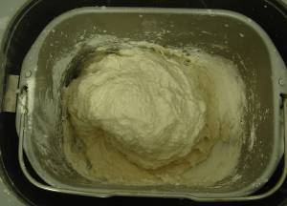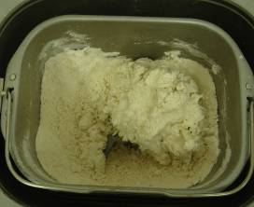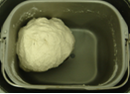

Too Much Water

Lacking of Water

Suitable Water

①When too much water is added, the dough will become so soft that can’t be rounded and even become sticky. If so, the bread made out would be very hard and with a flat or rough surface and a texture with bigger pore, no elasticity. The good bread should be half-rounded.
5minutes after adding water the dough still is damp and sticky, please continue to add one or two big spoons of flour and knead the dough until you think the water content of dough is appropriate.
②If the water added is lacking, after 5minutes mixing you would find the dry flour was left on the bottom of barrel and the dough would not be fixed to a round shape. The dough would be with a flat or rough surface, no elasticity. If so, the bread made out would be also very hard and hold a texture with dense pores.
5minutes after adding water the dough still is dry too much, continue to add a big spoon of water and knead the dough until you think the water content of dough is appropriate.

Other Recipes
Sugar and eggs will make bread more colorful. Please add them as the amount recommended by Recipe Book. Adding them freely will bring a heavy color and even burn bread, and even finally result in stopping working in advance for avoiding burning bread. In addition, if you want to add egg, for egg will thin the mixture, please be sure to put just one egg beaten into measuring cup and add water to the specified level.

CLEANING AND MAINTENANCE
Keep Surface Clean
1. Unplug unit and disconnect electricity before cleaning.
2. Apply the small amount neutral cleaning solution to a clean and soft cloth and wipe the unit, and then dry it thoroughly with another dry cloth. Please don’t use gas oil or other abrasive cleansers and corrosive liquids to clean.

Keep Accessories Clean
1. After each use, clean the whole accessories used to avoid the accumulation of dirty.
2. If Stirring Rob are caught by barrel and doesn’t come off, you could pour an appropriate amount of water to steep for a while and then take Stirring Rod off.
3. If not use the unit for a long time, you should clean whole accessories and allow them to cool and store them into barrel.

Environment for Use
1.Appropriate temperature for use is 14°F～104°F.
2.Air relative humidity should be lower than 95% and temperature should be 77°F.
3.Appropriate temperature for storage is -40°F～140.°F
4.No inflammable gas, corrosive gas or conducting dust in air.

TECHNICAL SPECIFICATION

Item No. | EP23609
Rating Voltage | AC120V～60Hz
Rating Power | 710W
Rating capacity | 2 .0LB

Notice: the technical parameters specified here are subject to change without notice.

PROBLEM SOLUTION
The answers corresponding to the questions mentioned here are for your reference only. If there are possible serious problems or damage with the machine, please contact maintenance service or dial service hotline for more help.
Defects | possible Issues | Solution
Bread Maker fails to mix flour and work | Check if plug into outlet | Press “Start/Stop/Pause” and Bread Maker begins to work
Bread Maker fails to mix flour and work | Check if operation is delayed | Indicator “:” is flashing, and countdown begins to work
Bread Maker fails to mix flour and work | Damage of Parts | Send To Maintenance Department
Abnormal Sound | There is a litter of hard stuffs or crumbs in barrel | Remove anything found inside the unit before re-start
Abnormal Sound | Lock Barrel into position | Re-place bread barrel into position
Abnormal Smell/Taste | Wire cord damaged | Keep wire cord away from heated objects
Abnormal Smell/Taste | something left on heating tube | Remove the matter left on heating tube
LED indicates”E00” | Temperature inside the unit lower than 14°F | Use the unit under the environment at 14°F～104°F
LED indicates “E01” | Temperature inside the unit higher than 122°F | use electric fan to cool it or naturally cool to be at room temperature
LED indicates “EEE” or ”HHH” | Defect with sensor | Sent to Maintenance Department
Bread is partly raw | Bread is raw | less water or water temperature is high
Bread is partly raw | The rate of material is wrong | Refer to Recipes Recommended

