EP24831
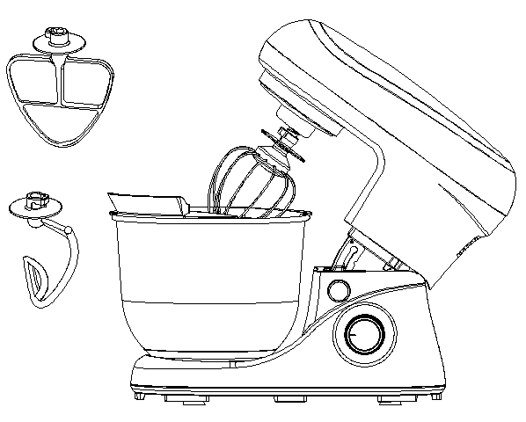

Food Mixer
SM-961
Food Mixer
Operation and Safety Notes

Read the operating instructions carefully before using the appliance for the first time and preserve this booklet for later reference. Pass the manual on to whomsoever might acquire the appliance at a later date.
Explanation of terms
The following keywords are used in these user instructions:
Warning!
High risk: ignoring this warning could result in a risk to life and limb.
Caution! | Medium risk: ignoring this warning may result in damage.
Note: | Low risk: points to be noted when handling the appliance

Special information about this appliance
 |  | Warning! To avoid injury or damage, please observe the following information
1. | The appliance may only be used by persons with reduced physical, sensory or mental capabilities, or lacking experience and knowledge, if they have been given supervision or instruction concerning the use of the appliance and fully understand all dangers and safety precautions involved.
2. | Children must not be permitted to operate the appliance. The appliance and its power cord must be kept well away from children.
3. | Children must not be permitted to play with the appliance.
4. | The appliance must not be operated with an external timer or separate remote control system such as a remote control socket
5. | Always remove the power supply plug from the mains socket before starting to clean the appliance.
6. | Never immerse base unit in water.
7. | Never use abrasive, corrosive or scratching cleaning materials. They could damage the appliance.

General information
1. | Use the appliance only for the purpose described.
2. | To prevent damage, check that the mains voltage required is compatible with your mains voltage.
3. | Only use one attachment at a time!
4. | Before cleaning the appliance, ensure it is disconnected from the power supply and has cooled down completely.
5. | Caution! Any misuse can cause severe personal injury.

Protection against electric shock
 |  |  | Warning! The following safety information is intended to protect you against electric shock.
1. | The appliance must not under any circumstances be used if it is damaged. Have the device repaired in such cases by a qualified specialist.
2. | If the mains cable for this appliance is damaged, it must be replaced by the manufacturer or a person with similar qualifications in order to avoid a hazard.
3. | Under no circumstances should water or other liquids get into the base unit. For this reason:
 | - | never use it outdoors
 | - | never immerse the base unit in water
 |  | never place containers filled with liquid, such as drinking glasses, vases etc. on the appliance
 |  | never use in very humid environments
 |  | never use in the immediate vicinity of a kitchen sink, bath, shower or a swimming pool, as water may splash into the appliance
 | If liquid should enter the appliance, unplug the mains plug immediately and have the appliance repaired by a qualified technician.
4. | Never touch the appliance, the mains cable or the mains plug with wet hands.
5. | Always unplug it by pulling out the plug, never pull on the cable itself.
6. | Ensure that the mains cable is not kinked, twisted or crushed.
7. | Keep the mains cable away from hot surfaces, such as the top of a stove.
8. | If you are not going to use the appliance for a while, remove the plug from the wall socket. Only then is the appliance completely free of current.

Preventing injury
 |  |  | Warning! To avoid injury, please observe the following information.
1. | Make sure that the mains cable never becomes a trip hazard, that no-one can get tangled in it or tread on it.
2. | During operation, avoid contact with the moving parts of the appliance such as the dough hook, balloon whisk or beater. Your hands or hair could be drawn into the appliance, leading to injuries. Only ever switch the appliance on if you have correctly fitted the splash guard when using the mixing bowl.
3. | Always remove the plug from the wall socket
 | - | when there is no supervision,
 | - | after each cycle of use,
 | - | in case of any malfunction,
 | - | before cleaning, assembling or disassembling the appliance,
 | - | before changing any attachment.
4. | This appliance is intended for domestic or similar applications, such as
 | - | by staff members in shops, offices and other similar working environments,
 |  | in agricultural working environments,
 |  | by customers in hotels, motels etc. and similar establishments,
 |  | in bed-and breakfast type environments.

Material damage
Warning! Follow the instructions given below to prevent material damage.
1. | Only place the appliance on a level, dry, non-slip surface to stop the appliance falling over or sliding off.
2. | Do not place the appliance on top of a hot stove.
3. | Never use the mixer when empty. This might cause the motor to overheat.
4. | Do not move the appliance if food or pastry is still inside.
5. | Do not overfill the mixing bowl as the contents might otherwise be ejected.
SAVE THESE INSTRUCTIONS

Short-time operation
The appliance has been designed for short-term operation only, ie it should not be operated continuously for more than 4 minute. Switch off the appliance afterwards and allow the motor to cool down before switching it on again.

Connection to the mains supply
Make sure that the supply voltage corresponds with the voltage marked on the rating label. This product complies with all binding CE labeling directives.

Technical Data
Nominal voltage: | 120V AC 60Hz
Power consumption: | 500W
Max. capacity [Mixing bowl]: | 5.0 l
Protection class: | II

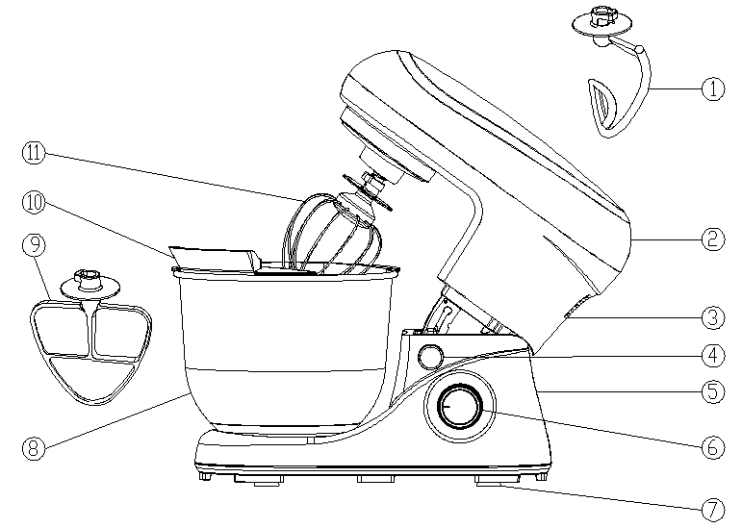RE
Familiarization
1 | Dough hook | 7 | Suction feet
2 | Top cover | 8 | Mixing bowl
3 | Upper housing | 9 | Beater
4 | Unlock lever | 10 | Balloon whisk
5 | Base unit | 11 | Splash guard
6 | switch

Unpacking and setting up
● | Unpack the appliance from the packaging.
● | Remove the transport packaging.
● | Check that the appliance shows no signs of damage.
● | Place the appliance on a level, dry, nonslip surface so that the appliance can neither fall over nor slide off.
● | Check that the speed controller is set to "0".
● | Put the plug in a suitable socket.
The appliance is now ready to use.

Operation
Assembling the appliance
1. | Press the unlock lever and swing up the drive arm.  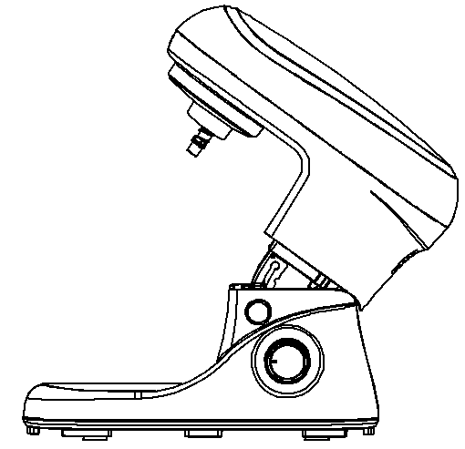
2. | To fit the mixing bowl, insert it in the base unit.
3. | Lock the mixing bowl by rotating it slightly anti-clockwise until it engages.  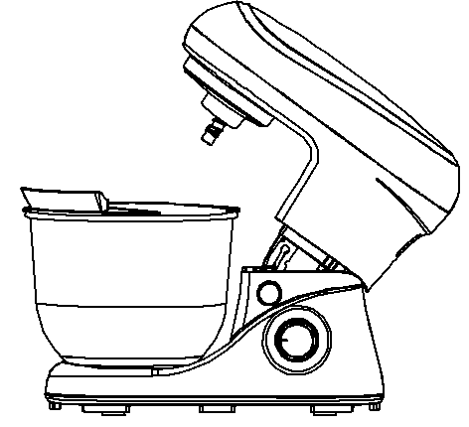
Caution!
Never use the mixing bowl without the splash guard in position. Otherwise food might be ejected.
4. | Fit the splash guard onto the drive arm from below. The filling opening with flap should point towards the speed controller.
5. | Press on the splash guard until it engages.
6. | Select the appropriate attachment:  Dough hook: For heavy dough, e.g. bread dough  Balloon whisk: For whipping cream, beating egg whites, etc.  Beater: For medium to light dough/batter, e.g. batter for (pan)cakes.
7. | Fit the attachment into the appropriate opening in the drive arm from below
When doing so, make sure that the little lugs on the shaft of the attachment are inserted into the crosswise slot of the opening.
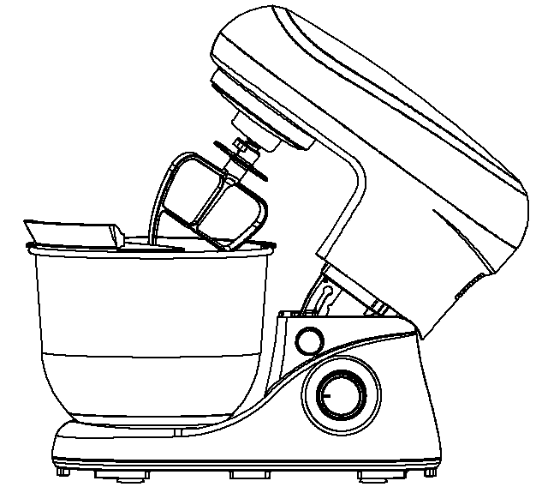
8. | Press the attachment lightly in and turn clockwise until it engages.
9. | Press the unlock lever and swing the drive arm down into the working position.  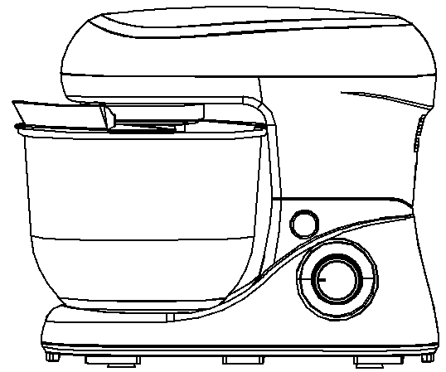
The appliance is now ready to use
Dismantle appliance
1. | Press the unlock lever and swing up the drive arm.
2. | To remove an attachment, press lightly in again and unlock by turning anticlockwise slightly.
3. | Remove the attachment.
4. | To remove the splash guard, pull it downwards. When doing so, first pull the splash guard down at the back slightly.
5. | Unlock the mixing bowl by rotating slightly in a clockwise direction.
6. | Remove the mixing bowl.
7. | Press the unlock lever and swing the drive arm down into the working position.

Regulating speed, switching on and off
1. | Switch the appliance on by turning the speed controller to the right.
2. | Start off at a slightly slower speed when mixing and then increase

Recommendations for speed levels
Speed | Attachment | Description
1-3 | All | - Starting position for all mixing operations.  - When adding ingredients.
 | Dough hook | - Kneading and mixing firm dough or ingredients.  Ingredients  ￭ 0.6 kg plain flour  ￭ 0.36 kg lukewarm water  Preparation  - Put the ingredients in the mixing bowl.  - Fit the splash guard and dough hook.  - Speed: 1st, knead for 15s on level 1.  2nd, knead for 15s on level 2.  3rd, knead for 3 minutes on level 3.
4-6 / Pulse button | Balloon whisk | - Whipping cream  - Egg whites  - Mayonnaise  - Beating butter until fluffy  Ingredients  ￭ 18 egg whites  Preparation  - Put the egg whites in the mixing bowl.  - Fit the splash guard and the balloon whisk.  - Beat the egg whites at level 6 for 4 minutes until stiff.

Cleaning the appliance
 |  | Warning! To prevent the risk of electric shock, injury or damage:
 |  | - | Disconnect the power supply plug from the mains socket before cleaning.
 |  | - | Never immerse the base unit in water.
Caution! Never use scouring, corrosive or abrasive cleaning materials as these could damage the appliance.
Cleaning the base unit
1. | Clean the base unit with a damp cloth. A little detergent may also be used.
2. | Wipe over with clean water.
3. | Do not use the base unit again until it is completely dry
Cleaning the splash guard, dough hook, balloon whisk and beater
Caution!
The dough hook, balloon whisk and beater can not be washed in the dishwasher.
1. | Put the parts in cold or lukewarm water to soften dough residues.  Note You can also add a little detergent to the water.
2. | Remove softened dough residues with a washing-up brush.
3. | Rinse off with clean water.
4. | Allow parts to dry completely before using them again.
Cleaning the mixing bowl
The mixing bowl is made of stainless steel and can be cleaned in the sink or dishwasher.

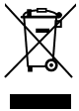 | At the end of its service life, this product may not be disposed of in the normal household waste, but rather must be disposed of at a collection point for recycling electrical and electronic devices. The materials are recyclable according to their labelling. You make an important contribution to protecting our environment by reusing, recycling or utilising old devices in other ways. Please ask the municipal administration where the appropriate disposal facility is located.

