BOX CONTENTS 1 OF 2
Box |  | Specifications | Qty
HW58907ES-12 |  | Assemble Instruction | 1 set
 |  | Hardware Pack | 1 pack
 | A | Lower Leg (Left Front & Right Rear) | 2pcs
 | B | Lower Leg (Left Rear & Right Front) | 2pcs
 | C | Upper Leg (Left Front & Right Rear) | 2pcs
 | D | Upper Leg (Left Rear) | 1pc
 | E | Upper Leg (Right Front) | 1pc
 | F | Headboard Frame | 3pcs
 | F1 | Footboard Frame | 1pc

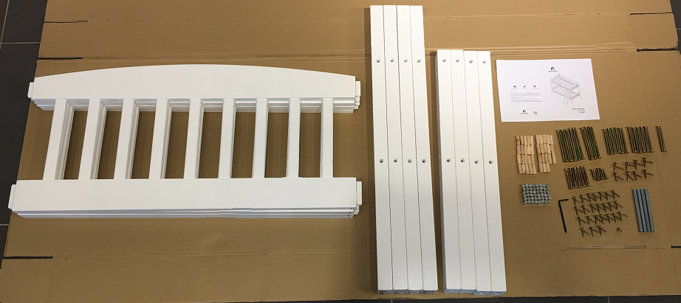

BOX CONTENTS 2 OF 2
Box |  | Specifications | Qty
HW58907ES-22 | G | Lower Side Rail | 2pcs
 | H | Upper Side Rail (Front) | 1pc
 | I | Upper Side Rail (Rear) | 1pc
 | J | Guard Rail (Rear) | 2pcs
 | K | Guard Rail (Front) | 2pcs
 | L | Guard Rail Support | 3pcs
 | M | Slat | 2sets
 | N | Ladder Rail (Left) | 1pc
 | O | Ladder Rail (Right) | 1pc
 | P | Ladder Stretcher | 5pcs

