BOX CONTENTS 1 OF 2
Box |  | Specifications | Qty
HW66963WH-12 |  | Assemble Instruction | 1 set
 |  | Hardware Pack | 1 pack
 | A | Lower Leg (Left Front & Right Rear) | 2pcs
 | B | Lower Leg (Left Rear & Right Front) | 2pcs
 | C | Upper Leg (Left Front & Right Rear) | 2pcs
 | D | Upper Leg (Left Rear) | 1pc
 | E | Upper Leg (Right Front) | 1pc
 | F | Headboard / Footboard Upper Rail | 4pcs
 | G | Headboard / Footboard Frame | 3pcs
 | H | Headboard / Footboard Frame with Sticker | 1pc
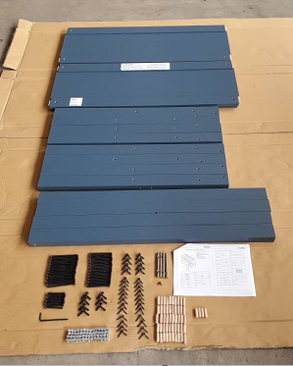
BOX CONTENTS 2 OF 2
Box |  | Specifications | Qty
HW66963WH-22 | I | Lower Side Rail | 2pcs
 | J | Upper Front Side Rail | 1pc
 | K | Upper Rear Side Rail | 1pc
 | L | Rear Guard Rail | 2pcs
 | M | Front Guard Rail | 2pcs
 | N | Guard Rail Support | 3pcs
 | O | Slat | 2sets
 | P | Left Ladder Rail | 1pc
 | Q | Right Ladder Rail | 1pc
 | R | Ladder Stretcher | 5pcs
