Hand blender Instruction manual
KC47194US (600W,120V,60HZ)
1. FOREWORD
Thank you for choosing our Lanb Hand blender products. This product is one of our new products that research and development independently.
Characterized by simplicity generosity, easy operation, functional maturation and easy cleaning, this product is a good helper of household kitchen.And it’s suitable for blending, cutting and mixing a variety of food.

2. SPARE PARTS AND INSTALLATION DARWING
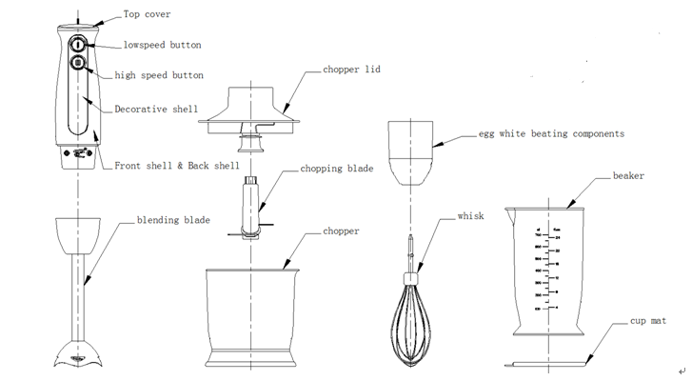

3. MAIN FEATURES
1) More functional accessories. Depending on the type, it can match blending rod, chopper, egg white, beaker, etc.
2.) According to the different types you choose,the product speed select-able and adjustable.Therefore it’s convenient to processing various types of food material.
3)Turn-lock clasp separation structure designed in main unit and each functional accessories. It is convenient to use any combination of different accessories

4. USER INSTRUCTIONS
1) How to use the blending blade
This accessory is special suitable for processing dip, sauce, soup, mayonnaise, baby or aged people food and mixed drinks, milk shake, etc.
Installing the blending blade turn-lock clasp on the main unit
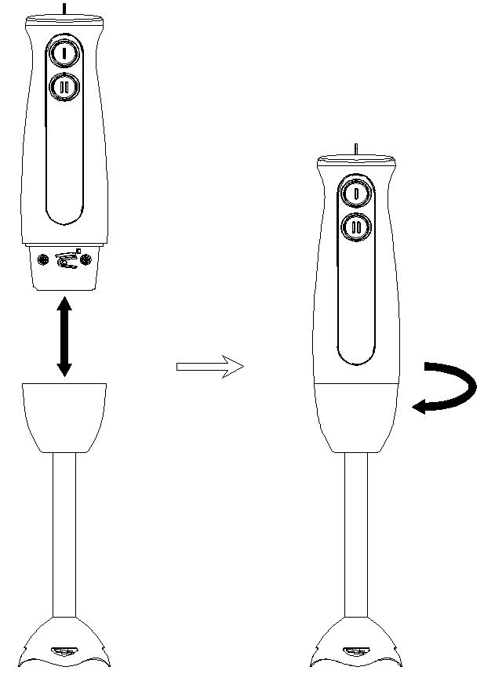
Cutting the food into cubic block that no more than 15 mm³, then put them into beaker and add some cold boiled water, or drinking water, milk,water,milk,etc.
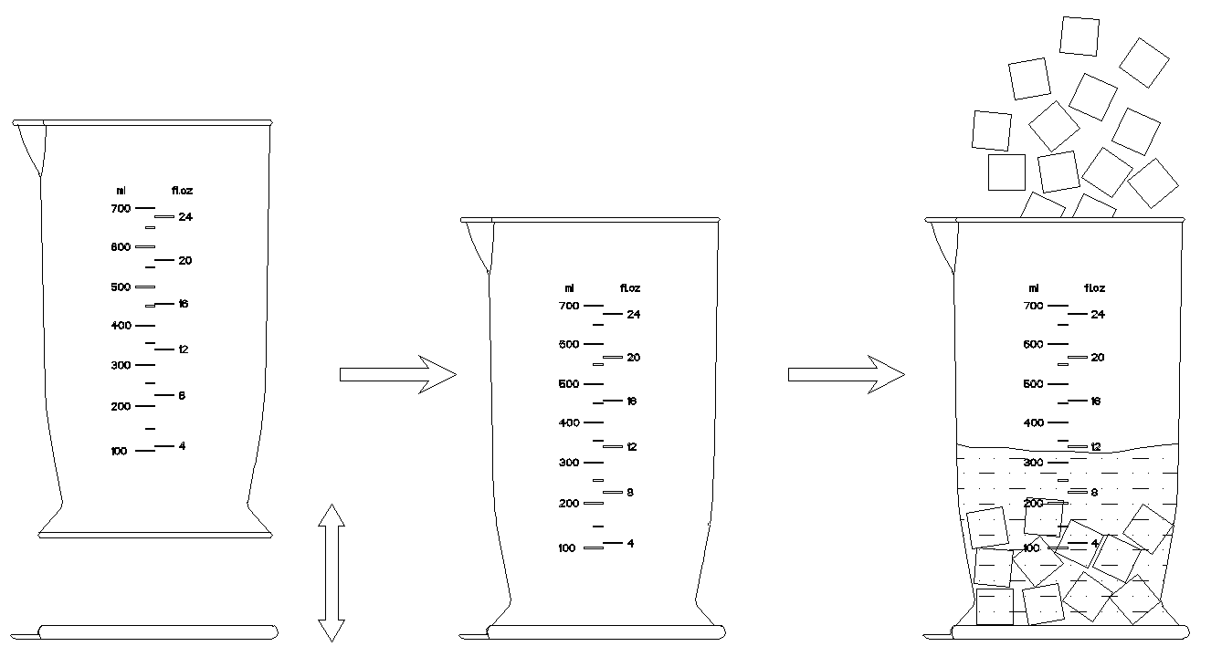
beaker and cup matplace the cup mat under the beaker add food
and water into beaker
plug the power cord into power socket
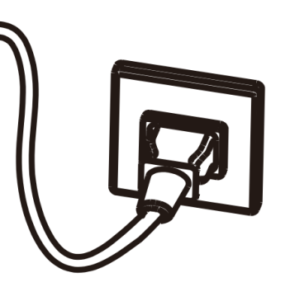
Put the blending blade into beaker
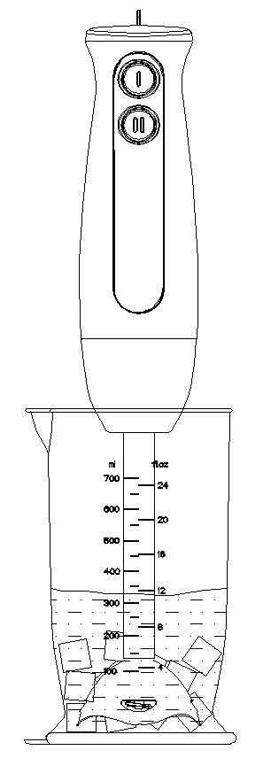
The product will continue to work by pressing on high or low speed button. In order to blend the food well and quickly, please use your one hand to hold the beaker, the other hand to hold the main unit to do up and down reciprocating movement. If you want to stop this product, just press on the switch button.
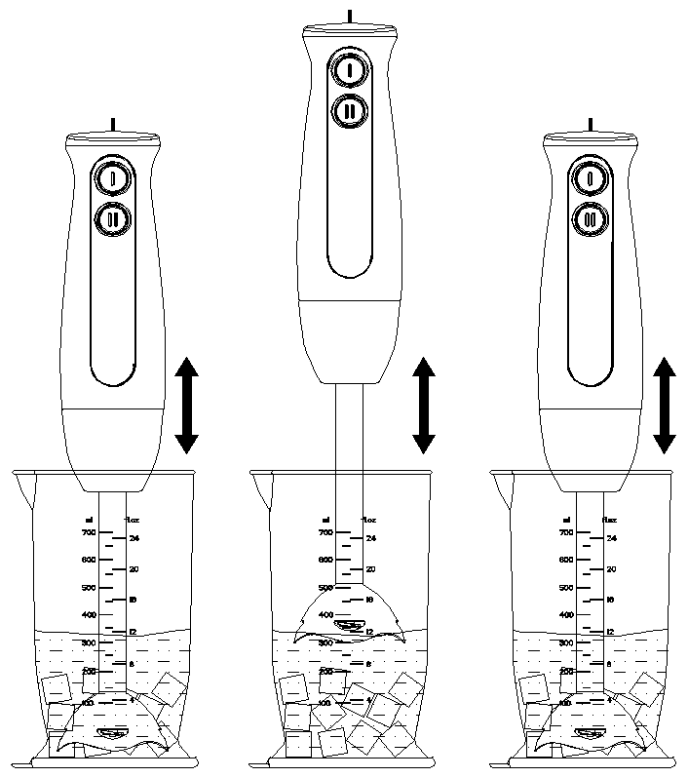

Pull the plug out of the power socket after working.
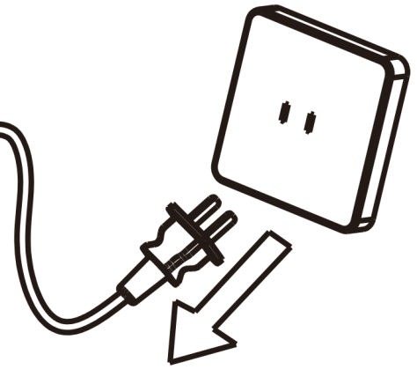
Attention：
- The accessories continuous working time should less than 1 minute. After working 1 minute, they need to rest for 1 minute.
- Regarding 1 minute at work and 1 minute at rest as a cycle. After continuously working 5 cycles, it must rest 30 minutes for motor cooling.
- In order to ensure the sealing effect of blending blade, please do not allow the blending blade to work without immersing into liquids.

2). How to use the chopper
This accessory is special suitable for chopping meat, ginger, garlic, and making carrot granule, chili sauce, etc.
Setting the chopping blade into chopper shaft
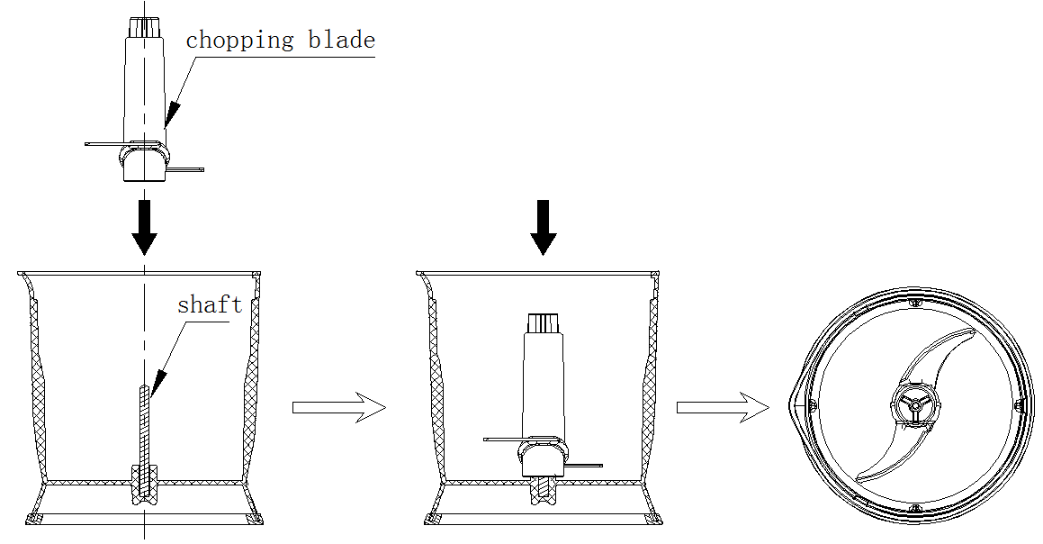
Cutting the food material into appropriate shape and size. For example: cut meat into 2cm*2cm* 6cm size; cut onion into 4-6 disc, etc. Put the ready food into chopper and lock the chopper lid.
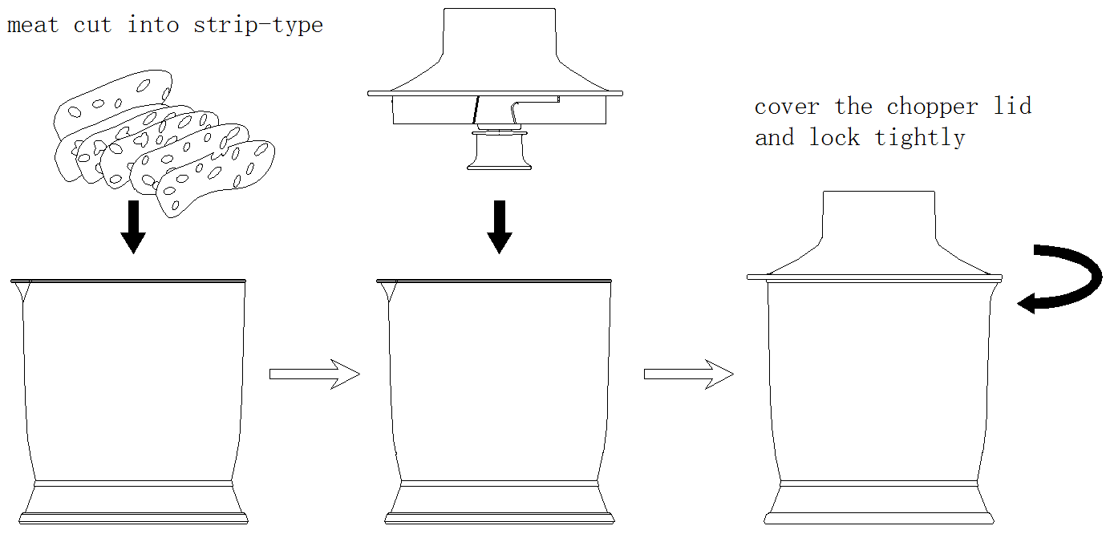
Let the main unit turn-lock clasp to the chopper lid, and then plug in and press the switch button. Once the food material chopped to your expected effect, just hand off the switch button, and the product will stop working. Finally, you should unplug the power cord firstly and then pour out the processed food.
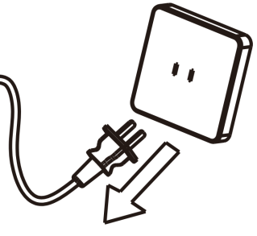
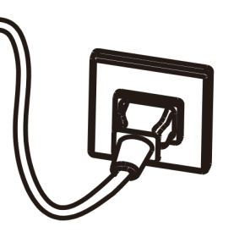
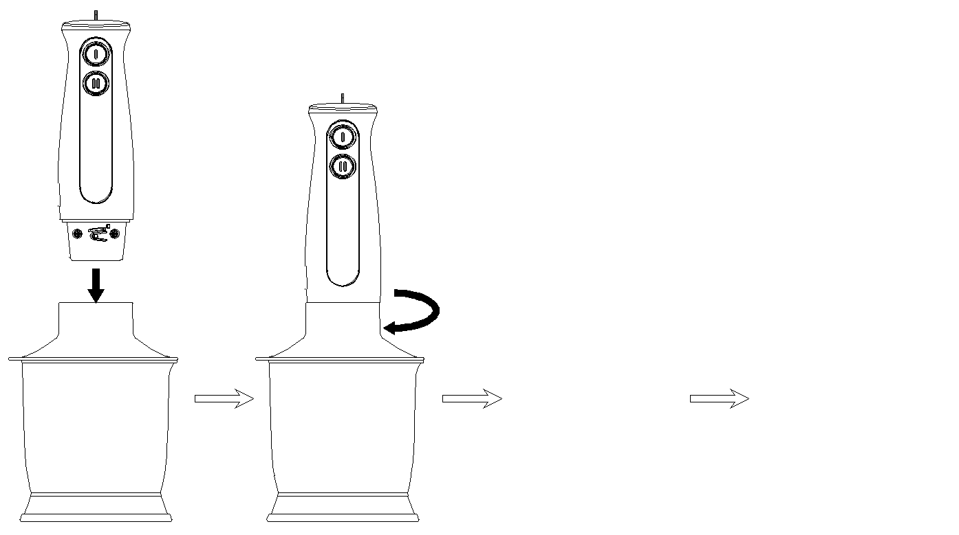
Attention:
- Maximum capacity can't more than 300 grams per time when meat chopping
- The continuous working time should less than 10 seconds when meat chopping. After working one time, they need to rest for 2 minutes.
- Regarding 10 seconds at work and 2 minute at rest as a cycle. And after continuously working 3 cycles, it must rest 30 minutes for motor cooling.
Some operation tips:
- High speed button should be used when meat chopping, especially the turbo function, as it only takes about 10 second and the meat foam taste better. Overtime processing will destroy the meat fibers and not taste good.
- It is recommended to use low speed button when chopping carrots, ginger, garlic and pepper particles. Turn to the low speed to work around 15 seconds can get better effect.
- The best food material to process meat: Lean beef without tendon, lean pork without pigskin and bone. The proportion of fat meat should not exceed one fifth of the whole piece of chopping meat, otherwise it will affect the chopping effect.
3) How to use the egg white beating components
Inserting the whisk into egg white beating components, and then lock it to the main unit.
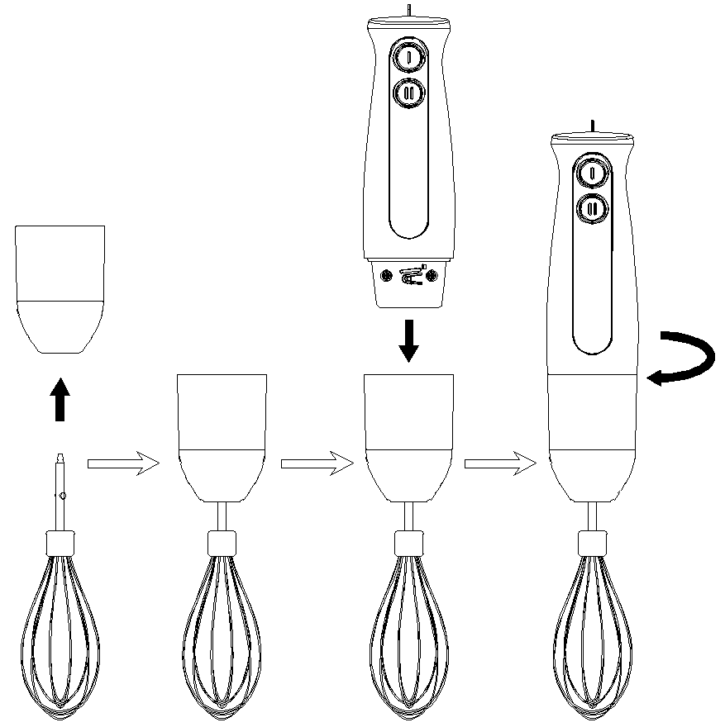
Adding egg whites of 2-3 eggs into beaker, and then put the whisk into it. Plug in and use high speed button to work. Once the egg white formed foam, hand off the switch button and the product will stop working. Finally, unplug the power cord.
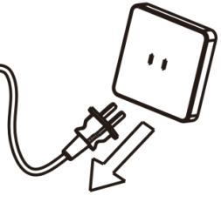
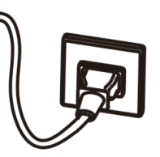
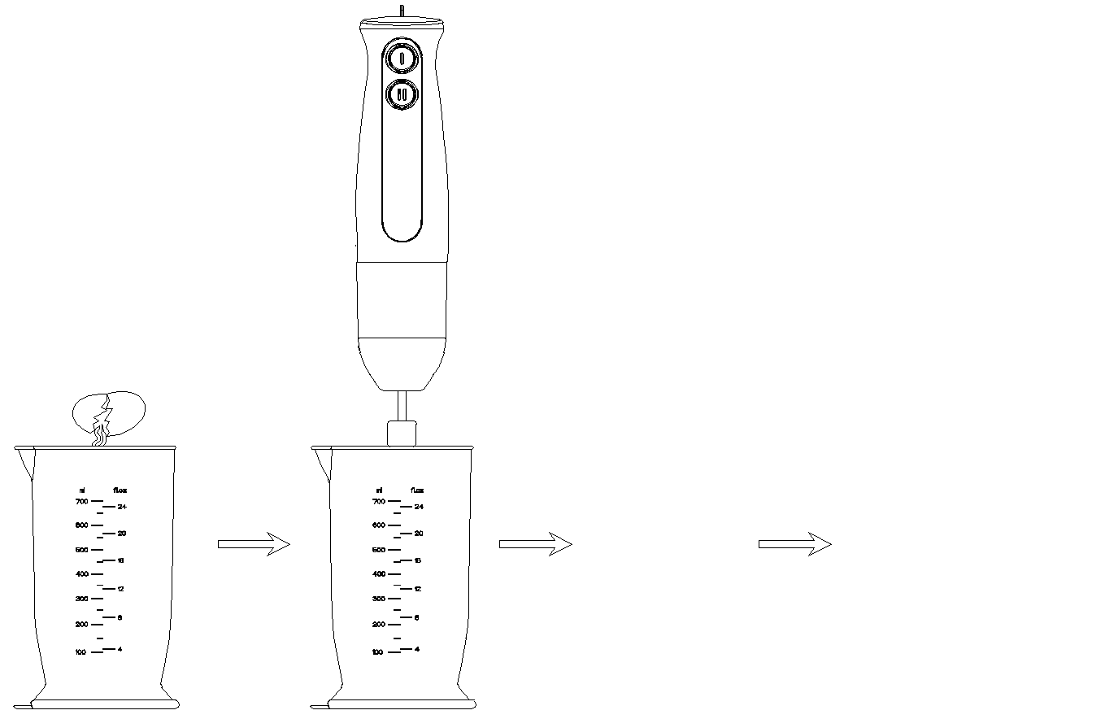
Warm prompt:
The optimum efficiency after mixing: Put the cup upside down, and there is no egg white liquid flow out.
5. REFERENCE TABLE FOR FOOD PROCESSING SIZE AND CAPACITUY
Food material | Processing size | Maximum processing capacity of chopper | Maximum processing capacity of beaker | Processing time  （seconds） | Speed button choosing
beef | 2cm×2cm×6cm | 300g | / | 8-10 | high speed button
carrot | cut into 4 pieces | 300g | 200g+300g  (food+water) | 30-40 | low speed button
garlic | Peeling disc | 100g | / | 20-30 | low speed button
onion | cut into 8-16 disc | 300g | / | 5-10 | low speed button
apple | cut into 4-8 disc | 500g | 200g+300g  (food+water) | 30-40 | low speed button
egg white | / | / | egg white of 3-4 eggs | 60 | high speed button

6. IMPORTANT SAFEGUARDS
1) In order to avoid a risk of electric shock or fire, please do not use power supply except for AC 110V-120V.
2) Please exclusive use a socket that more than 6A specification. If shared use the socket with other electrical appliances, the socket circuit part may occurs abnormal heat and on fire.
3) Please do not use the ironmongery hard things to scrape the product.
4) You must pull out the power cord plug after using to avoid the risk of electric shock, electric leakage fire disaster.
5) The product will automatically stop working when it overheating. please unplug the power cord plug.
6) Please disconnect the machine's power supply connection before dis-assembly and assembly and cleaning or when not in use.
7) Please do not put overheating(over 60 degree centigrade) and overmuch food material into cup to avoid liquid spills, overflow, and resulting in personal injury.
8) The use of attachments not recommended or sold by manufacturer may cause personal injury.
9) Ensure all parts are installed in place and the lock tight during the operation.
10) This product continuous working time should less than 1 minute. After working 1 minute, they need to rest for 1 minute. Regarding 1 minute at work and 1 minute at rest as a cycle. after continuously working 5 cycles, it must rest 30 minutes for motor cooling.
11) The beaker, chopper, food processing cup, etc. are not microwave proof.

7. WARNING
1) In addition to the professional repair technicians , other person please do not dis-assembly, repair and refit the product, as it will give rise to on fire, electric leakage and abnormal operation.
2) Please place this product where children can't reach.
3) Please do not use wet hand to pull or plug the power cord in order to avoid electric shock and court-circuit.
4) Please do not wet or immerse the main unit in order to avoid electric shock and
court-circuit.
5) For indoor household only, please do not use for commercial purposes.
8. CLEANING AND MAINTENANCE
1) You should unplug the power cord plug before cleaning.
2) Do not touch the sharp blade.
3) Please use dry dishcloth to wipe the product body. And it is strictly prohibited to let the main unit rinse with water or immerse to the water.
4) Please do not use metal brush, nylon brush, household cleanser, diluent and other similar cleaning supplies to clean this product, as they may damage the product surface structure.
5) Please use soft dry cloth to wipe the dirt on the power cord.
6) The cleaning requirements of each functional accessories.
Cleaning  Accessories | scrubbing | Rinsing | Immersion cleaning | Dishwasher | Remark
Blending blade | √ | √ | × | × | Do not immerse  into water
egg white beating components | √ | × | × | × | Do not immerse  into water
whisk | √ | √ | √ | √
Chopper lid | √ | × | × | × | Do not immerse  into water
Chopper | √ | √ | √ | √
Chopping blade | × | √ | √ | √

9. COMMON PROBLEM ANALYSIS
phenomenon | Reasons | Handling method
The motor running, but the blade doesn’t work | 1) The functional accessories does not lock well with the main unit  2). The blade is entangled by food material and stuck | 1) Lock them well  2) Pull the plug out, and then take out the food material and cut them into small pieces
The product suddenly stops working in the processing of using | 1). Using for a too long time, and the motor overheating and damaged  2). The plugs loose or power failure | 1) Working time should strictly according to the instruction manual  2) Excluding this problem after checking
Abnormal vibration or excessive noise | 1) The functional accessories does not lock well with the main unit  2) Putting into too much food material | 1) Lock them well  2) Pull the plug out, and then take out the excess food material, and choose low speed to work
The product doesn’t work after plugging in the power cord and pressing the on-off key | 1) Power failure or power socket in the closed state or plug loose  2) Electronic board damage or motor damage | 1) Excluding this problem after checking  2) Have a repair service
Remark:
If still unable to troubleshooting after the above phenomenon analysis, please contact our maintenance personal or the dealer. It is forbidden to dis-assembly by non-professional personnel.

10. LINE GRAPH OF THE WHOLE PRODUCT
