USER’S MANUAL

Model: PH050017 (OP3244BK/OP3244WH/OP3458BE/OP3458CF）
PH050018 (OP3245BK/OP3245WH/OP3465BE/OP3465CF),
110V~, 60Hz, 1500W

Shanghai Qinxu Plastic Products Co., Ltd.
5151, Dongchuan Road, Heqing Town, Pudong New Area, Shanghai, 201201, People’s Republic of China

Read this manual before operation

IMPORTANT SAFETY INSTRUCTIONS

WARNING1: The appliance should be supplied through a residual current device (RCD) with a rated tripping current not exceeding 30 mA.
WARNING2: Electric installations should fulfill the requirements of local standards. Earthed appliances must be permanently connected to fixed wiring
WARNING3: If the supply cord is damaged, it must be replaced by the manufacturer or its service agent or a similarly qualified person in order to avoid a hazard. Replace damage cord immediately.
WARNING4: Parts containing live parts, except parts supplied with safety extra-low voltage not exceeding 12 V, must be inaccessible to a person in the bath.
WARNING5: To reduce the risk of electric shock, do not use extension cord to connect unit to electric supply; provide a properly located receptacle.
WARNING6: Parts incorporating electrical components, except for remote control devices, must be located or fixed so that they cannot fall into the bath.
WARNING7: To avoid electric shock, do not use the spa when it is raining.
WARNING8: Never operate the spa if the suction fittings are broken or missing. Never replace a suction fitting with one rated less than the flow rate marked on the original suction fitting.
WARNING9: To reduce the risk of injury, do not permit children to use this product unless they are closely supervised at all times.
WARNING10: Water attracts children. Always have the spa locked with its cover after each use.
WARNING11: When the jet function is going to be used, make sure the cover of spa is opened first.
WARNING12: Do not switch on if there is any possibility that the water in the spa is frozen.
WARNING13: Risk of electric shock. Never operate any electrical appliance when in the spa or when your body is wet. Never place any electric appliance, such as a light, telephone, radio, or television, within 5 feet (1.5m)of a spa.
WARNING14: Pets should be kept away from spa to avoid damage.
WARNING15: Risk of electric shock. Install at least 5 feet (1.5m) from all metal surfaces. As an alternative, a spa may be installed within 5 feet of metal surfaces if each metal surface is permanently connected by a minimum 1.0 mm² solid copper conductor to the wire connector on the terminal box that is provided for this purpose.
WARNING16: Risk of accidental drowning. Extreme caution must be exercised to prevent unauthorized access by children. To avoid accidents, ensure that children cannot use this spa unless they are supervised at all times.
WARNING17: During pregnancy, soaking in hot water may cause damage to the unborn fetus.
Limit use to 10 minutes at a time.
WARNING18: The use of alcohol, drugs, or medication before or during the spa use may lead to unconsciousness with the possibility of drowning.
WARNING19: Obese persons and persons with a history of heart disease, low or high blood pressure, circulatory system problems, or diabetes should consult a physician before use a spa …
WARNING20: Persons using medication should consult a physician before using a spa since some medication may induce drowsiness while other medication may affect heart rate, blood pressure, and circulation.
The water in a spa should never exceed 40°C (104°F). Water temperature between 38°C (100°F) and 40°C (104°F). Are considered safe for a healthy adult. Lower water temperatures are recommended for young children and when spa use exceeds 10 minutes. Since high water temperature has a high potential for causing fatal damage during the early months of pregnancy, pregnant or possibly pregnant women should limit spa water temperature to38°C (100°F).
WARNING21: To reduce the risk of injury, never use water higher than 40°C (104°F) into the spa directly.
WARNING22: The use of alcohol, drugs, or medication can greatly increase the risk of fatal hyperthermia. Hyperthermia occurs when the internal temperature of the body reaches a level several degrees above the normal body temperature of 37°C (98.6°F). The symptoms of hyperthermia include an increase in the internal temperature of the body, dizziness, lethargy, drowsiness, and fainting, The effects of hyperthermia include failure to perceive heat; failure to recognize the need to exit the spa; unawareness of impending hazard; fatal damage in pregnant women; physical inability to exit the spa; and unconsciousness resulting in the danger of drowning.
WARNING23: Prolonged immersion in a spa may be injurious to your health.

IMPORTANT SAFETY INSTRUCTIONS

CAUTION1: To avoid damage to the pump, the spa must never be operated unless the spa is filled with water.
CAUTION2: Immediately leave spa if uncomfortable or sleepy.
CAUTION3: Place only on surface that can withstand the floor loading requirement of your spa.
CAUTION4: The spa should not be setup or left out in temperature lower than 4°C (40°F).
CAUTION5: Never add water to chemicals. Always adding chemicals to water may result in a hazardous chemical spray.
CAUTION 6: In order to avoid a hazard due to inadvertent resetting of the thermal cutout, this appliance must not be supplied through an external switching device, such as a timer, or connected to a circuit that is regularly switched on and off by the utility.
CAUTION 7: This appliance is not intended for use by persons (including children) with reduced physical, sensory or mental capabilities, or lack of experience and knowledge, unless they have been given supervision or instruction concerning use of the appliance by a person responsible for their safety.
CAUTION 8: Children should be supervised to ensure that they do not play with the appliance.
CAUTION 9: The spa should not be setup or left out in temperatures lower than 4°C (40°F)

After the spa being installed, please install the warning label on where is at a distance within 1.5m to the Spa, thus the users in spa can see the warnings clearly.
For the first time users, please ask him/her read the warnings carefully.
If the warning label is damaged or missing, please contact our Spa service center to get a new one.

SAVE THESE INSTRUCTIONS

SPECIFICATIONS
Model: PH050017（OP3244BK/OP3244WH/OP3458BE/OP3458CF）
Seating capacity: 4
Water capacity: 800L/211 gallon
Outer diameter: 1.85 m/73”
Inner diameter: 1.40 m/55”
Height: 0.65 m / 25.6”
Number of air jet: 130 X φ 3 mm
Power rated: 110V~, 60Hz
Heater: 900W/1.22HP
Jet: 600W/0.81HP
Power cable length: 3.3 M / 10.8feet
Filter: AC 110-120V, 60Hz 40W, 1880L/420gallon/H
Top lid: Polyester laminated PVC with foil
Cord-mounted： GFCI

Model: PH050018（OP3245BK/OP3245WH/OP3465BE/OP3465CF)
Seating capacity: 6
Water capacity: 1000L/264 gallon
Outer diameter: 2.08 m/82”
Inner diameter: 1.60 m/63”
Height: 0.65 m / 25.6”
Number of air jet: 130 X φ 3 mm
Power rated: 110V~, 60Hz
Heater: 900W/1.22HP
Jet: 600W/0.81HP
Power cable length: 3.3 M / 10.8feet
Filter: AC 110-120V, 60Hz 40W, 1880L/420gallon/H
Top lid: Polyester laminated PVC with foil
Cord-mounted： GFCI
INSTALLATION INSTRUCTION
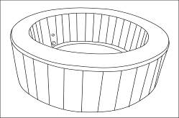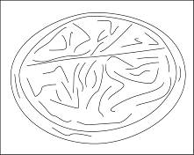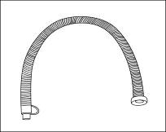
a b c
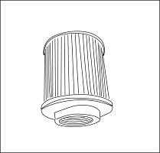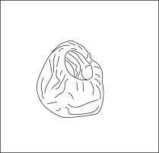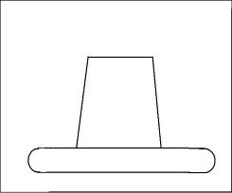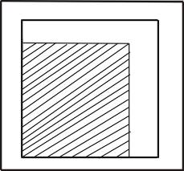
d e f g
Figure a
A Ensure to check all parts are present:
a. Spa pool
b. PU cover with foil and zipper
c. Inflation hose
d. Filter cartridge
e. Filter cartridge cover
f. Rubber plug
g. Repair kit
B Site requirements:
WARNING1: The floor has to be capable of supporting the expected load.
WARNING2: An adequate drainage system has to be provided to deal with overflow water.
IMPORTANT: Because of the combined weight of the spa, water, and users, it is extremely important that the base where the spa is installed is smooth, flat, level and capable of uniformly supporting this weight for the entire time the spa is installed. If the spa is placed on a surface, which does not meet these requirements, any damage caused by improper support will void the warranty. It is the responsibility of the spa owner to assure the integrity of the site at all times.
- Indoors installation:
Be aware of special requirements if you install the spa indoors.
  - The floor must be able to withstand the capacity of the spa. The floor should be a non-slip, level surface.
  - Proper drainage is essential for indoor spa installation. When building a new room for the spa it is recommended that a floor drain be installed.
  - Humidity is a natural side effect of spa installation. Determine the effects of airborne moisture on exposed wood, paper, etc. in the proposed location. To minimize these effects it is best to provide plenty of ventilation to the selected area. An architect can help determine if more ventilation is needed.
NOTE: Do not install the spa on carpet or other material that can be damaged by moisture.
- Outdoors installation:
  - No matter where you install the spa, it is important you have a solid support foundation. If you are installing the spa outdoors, ensure there are no sharp objects that could damage it and that the location is level so the spa sits stably and properly.
  - During filling, emptying or when in use, water may spill out of the spa. The spa should be installed near a ground drain.
  - Do not leave the spa’s surface exposed to direct sunlight for long periods of time.

C Assembly
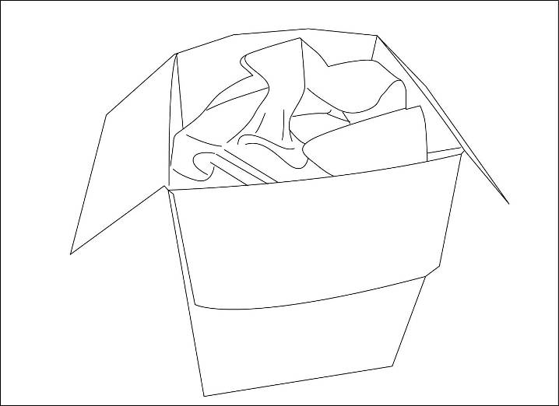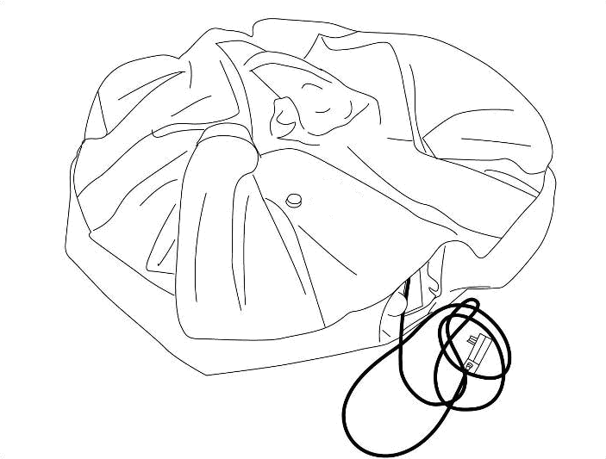

1
1. Unfold the spa from the packaging. Spread the spa and cover. Make sure both are right side up.

2. Open the air outlet on the spa. Screw one end of the inflation hose onto it.
3. Open the air valve on the spa. Connect the other end of inflation hose into the valve.
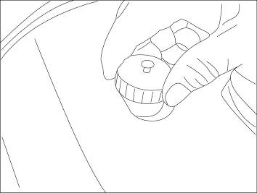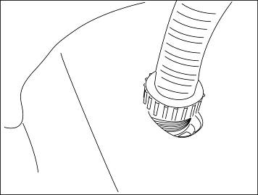

2

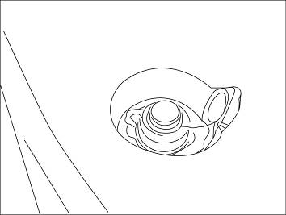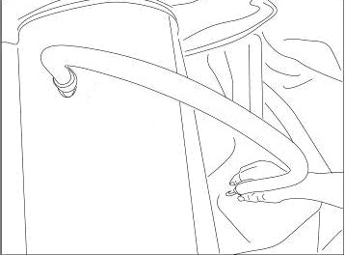

3

4. Inflate the spa tub by pressing the “Jet” button.
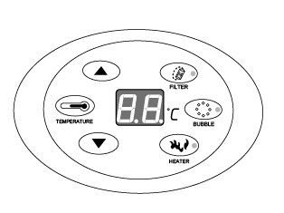
4

When the spa is properly inflated, press the “Jet” button to shut off the bubbles.
Attention 1: Do not over inflate.
Attention 2: If you want inflation when the spa has filled water, you must put on the Jets 2-3minutes by pressing the “Jet” button first, and then operate according to step 2-5 above.
5. Remove the inflation hose and screw the valve tight.
6. Remove the inflation hose from the air outlet and screw the nut tight.
7. Screw the filter cartridge onto the water inlet on the spa wall by turning it clockwise.
8. Fill the spa using a garden hose to fill to the water level printed on the spa wall.
9. Place the cover onto the spa, fasten the zipper.
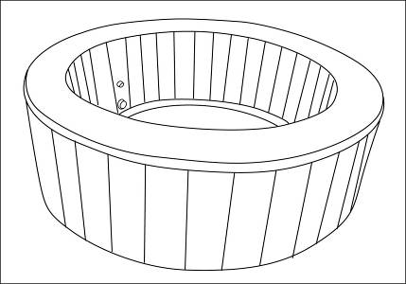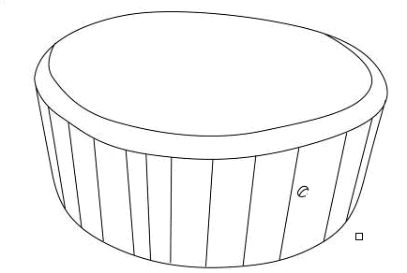

89

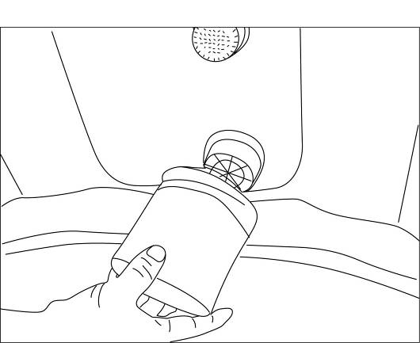 7 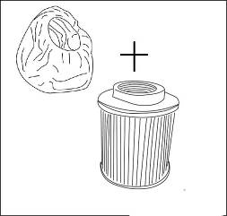

OPERATION
Figure j
A You must ensure the water in the spa matches the water line printed on the spa wall. Never dry-run the power pack as such type of operation will void the warranty.
B Control panel
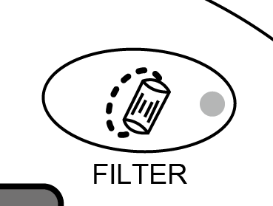 FILTER Key - On-off key for the filtration system. Press this key, and the filter pump will start working and the red indicator lamp will be on. Press again the pump will stop working and the lamp will be off.
When the FILTER PUMP has worked for 168 hours, the letters ‘FC’ will appear on the display screen, accompanied by a warning tone. At that time, the indicator lamp for the key of filtration system will be on but the filter pump will actually not work. The indicator lamp for the key of heating system will be off and the heating system will not work. Only by pressing the key ‘FILTER’ again can the indicator lamp for the key of filtration system be off. At that time, the letters ‘FC’ on the display screen will disappear and so will the warning tone. Actual water temperature will be displayed. All keys return to normal working status.
‘FC’ and the warning tone are to remind the user to clean or replace the filter element.
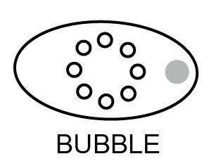 Jet Key - On-off key for the jet system. Press this key and the air pump will start working and the red indicator lamp will be on. Press again and the jet system will stop working and the lamp will be off. The jet system will stop automatically after working for 20 minutes. If there is still need, you have to wait for 10 minutes and then press the “Jet” key again.
During the time period which the bubbling function has been started and worked for 15 minutes, bubbling can be stopped or started. During the time period that the jets have been worked for 15 minutes and stopped, bubbling can be stopped but not be started. The re-starting of jets should wait for 10 minutes. When the jets have been on for 20 minutes and stopped, the function cannot be started again within 10 minutes.
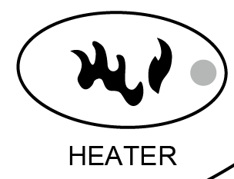 HEATER Key - On-off key for the heating system. Press this key the heating system will start working and the red indicator lamp will be on. Press again and the heating system will stop working and the lamp will be off.
When pressing down the key ‘HEATER’, the heating system will start working and the red indicator lamp will be on. At the same time, the red indicator lamp of the key FILTER will also be on and the filter pump will start working, too. This is a normal phenomenon required by the design.
When the preset temperature has been reached, the heating system will stop working while the heating indicator lamp will not turn off. The filter pump will stop working and the filtration indicator lamp will be off. When the water temperature falls to 2 below the preset temperature, the heating system will start working automatically and so will the filter pump. The filtration indicator lamp will be on.
TEMPERATURE Key – Key for setting temperature. Press this key and the numbers on the display screen will start flashing, and the keys for increasing or decreasing temperatures can be pressed to set the temperature. When settings are finished, press the TEMPERATURE Key again to confirm. Default temperature is 40°C, and temperature can be set in the range of 20-42°C.
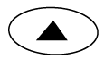 ------ Key for increasing temperature
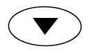 ------ Key for decreasing temperature

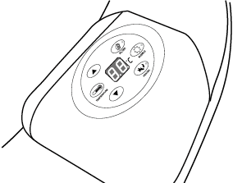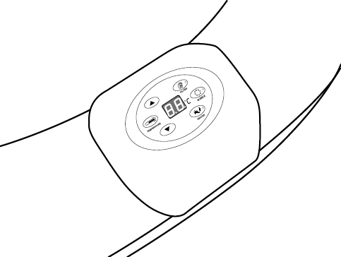
Base of the controller is made of environmental-friendly PU material that is soft and comfortable. Surface of the base can be washed.
The controller is chrome-plated, which meets ROHS standards.
Surface films are glued to the controller by marine glue.

Body of spa:
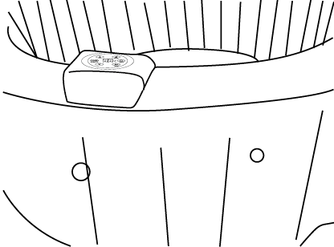
1. Water filling of water tank body: water should be filled to a position 20mm higher than the water line. If lower, heating may not be realized. If higher, water may spill over the tank in use.
2. Maintenance of water in the water tank body
2.1 Water in the water tank body should be filtered at fixed time regularly. It is not suggested to filter the water at all times.
2.2 Water in the water tank body should be treated with chemical agents periodically. However, chemical agents with calcium ions must not be used. If chemical agents with calcium ions are used for water treatment, there will be very likely to form scales on the walls of water tank and inner heating pipes. Water scales will directly damage the inner electrical components inside the control cabinet and further affect the service life of control cabinet.
2.3 If the filtration system has worked for 168 hours, the system will emit a warning tone to remind the user to clean or replace the filter element.
3. Conservation of SPA
Drain off the water inside the water tank completely and wipe off droplets of water on the walls. After that, lay aside the SPA for 24 hours, exhaust the air and fold. If it is Winter, please fold the SPA indoors. Because outside temperature in Winter is very low and materials may become hard. In that case, folding the materials may result in breakage. Put the SPA inside the packing case after folding it well and then put the case in a shaded place to avoid direct sunlight.

MAINTAINING
A Maintaining water
1. Clean your filter cartridge at least once a time after it worked continuously for 72- 120 hours. The filter cartridge should be replaced at least once a month depending on use.
2. Change water every few days or use appropriate pool chemicals. All spas require the use of pool chemicals. Please consult your local pool supply retailer for more information about chemical maintenance. Pay close attention to the chemical manufacturer’s instructions. Spa damage resulting from misuse of chemicals and mismanagement of spa water is not covered by the warranty.
- Water balance; we recommend maintain your water PH between 7.2 and 7.8, total alkalinity between 80 and 120ppm and free chlorine between 3 to 5ppm.
Purchase a test kit to test your water chemistry before each use of the spa, no less than once per week. Low PH will damage to the spa and pump. Damaged resulting from chemical imbalance is not covered by the warranty.
- Water sanitation is the responsibility of the spa owner, achieved through the regular and periodic (daily, if necessary) addition of an approved sanitizer. The sanitizer will chemically control bacteria and viruses present in the fill water or introduced during use of the spa.
B Cleaning the filter cartridge
1. Make sure to unplug the power pack from the electrical receptacle before the following actions.
2. Unscrew the filter cartridge by turning counterclockwise.
3. Remove the filter cartridge cover.
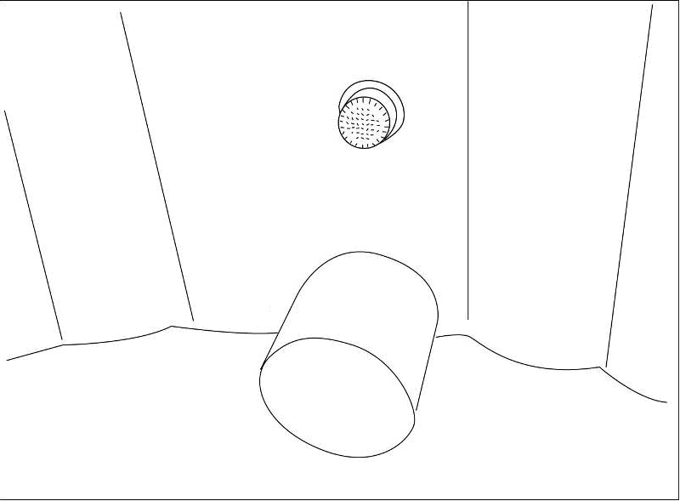  2 |  | 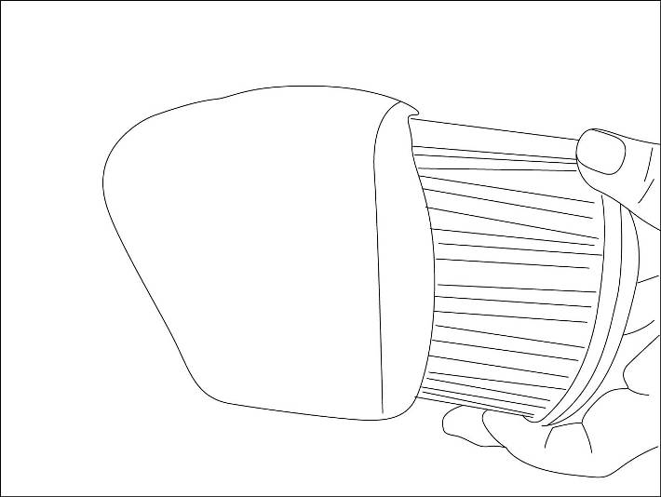  3

4. The filter cartridge can be rinsed off with a garden hose and reused. However, if the filter cartridge remains soiled and discolored the filter cartridge should be replaced.
5. Put on the filter cartridge cover and place the filter cartridge to water inlet by turning it clockwise.
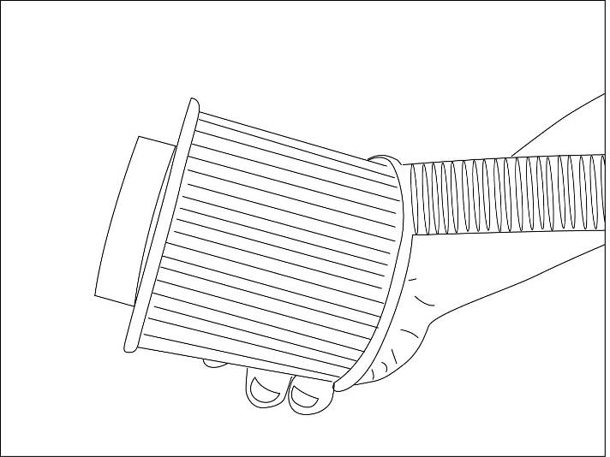
4

5

C Drainage
1. Make sure to unplug the power pack from the electrical receptacle.
2. Put the plastic plug into the outlet in the inner wall of the spa.

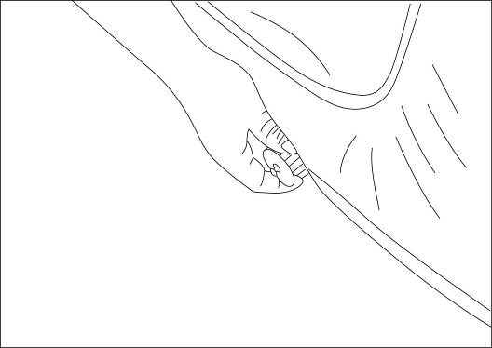 |  | 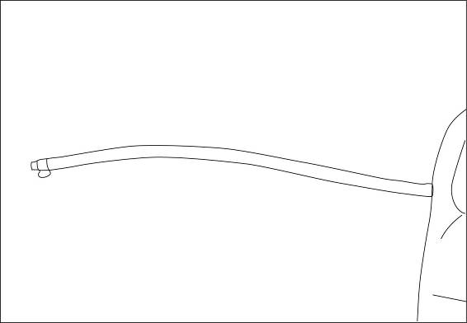

3. Open the outlet in the outer wall of the spa. Screw one end of inflation hose into it.
4. Pull the plastic plug off from the outlet in the inner wall of the spa, then the water will flow out.
5. When there is no water in the spa, you must put on the jet function 2-3minutes by press the “Jet” button to drain the water in the air pipeline.
6. When drainage is finished, remove the inflation hose and screw the nut tight.

D Cleaning the spa
Detergent residues and dissolved solids from bathing suits and chemicals will gradually accumulate in the spa’s water. To clean the spa, use soap and water then rinse.
Note: do not use hard brushes or abrasive cleaners.

REPAIR AND STORAGE
- Spa repair
If the spa is torn or punctured, use the provided repair patch. Dry the area to be repaired. Apply the glue in the accessory bag to the repair patch and then attach it onto the damaged area. Smooth the surface to remove any air bubbles. A secure unnoticeable repair can usually be made.
- Spa storage
Make sure all water is drained from the spa and control box. This is essential to extend the life of the spa. We recommend the use of a wet/dry vacuum to blow out or suck up water from the spa pipes and pump lines. Remove the filter cartridge.
It is recommended you store the spa in its original package in a warm dry place.
Note: Plastic becomes brittle and susceptible to breakage when exposed to subzero temperatures. Freezing can severely damage the spa. Improper winterization of your spa may void your warranty.

TROUBLE SHOOTING
Here are some helpful tips to help you to diagnose and rectify some common sources of trouble.
Problems | Probable causes | Solutions
Jet system does not operate | ---Air pump is too hot  ---Something is wrong with the power box | ---Unplug the air pump. After the air pump has cooled, insert the plug and press the Jet button to activate.  --- Call for service if it does not reset.
Heating system does not operate | ---Temperature set too low  ---Dirty filter cartridge  ---Improper water levels  ---Heating element failed | ---Set to a higher temperature (20-42°C).  ---Clean/replace the filter cartridge in time.  ---Add water to specified levels.  --- Call for service.
Filtering system does not operate | ---Dirty filter cartridge  ---Something is wrong with the power box  ---Too low voltage or incorrect frequency | ---Clean/replace the filter cartridge in time.  ---Call for service if it does not reset.  ---Ask professional electrician to check whether the household input voltage or frequency is normal
Spa leakage | ---Spa is torn or punctured | ---Use provided repair patch
Water not clean | ---Insufficient filtering time  ---Dirty filter cartridge  ---Improper water maintenance | ---Increase filtration time.  ---Clean/replace the filter cartridge.  ---Refer to the chemical manufacturer’s instructions.

WATER PROTECTION LEVEL
Warning: Water protection levels of appliance at different product zones are different. See the below scheme:
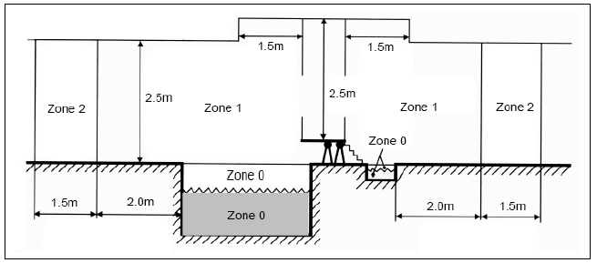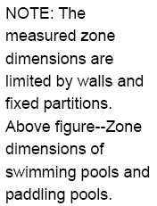
Zone 1
Note: The measured zone dimensions are limited by walls and fixed partitions. Above figure—Zone dimensions of swimming pools and padding pools.

- SAFETY & ANNOUNCEMENTS
      - A local supplementary equipotent bonding shall connect all extraneous conductive parts in Zones 0, 1 and 2 with protective conductors of all exposed conductive parts situated in these zones.
- The measures of protection by non-conducting location and by earth-free equipotent bonding are not permitted.
- Electrical equipment shall have at least the following degrees of protection:
- Junction boxes shall not be installed in Zones 0 and 1 except in zone 1, where permitted for SELV circuits.
- In Zone 0: IPX8
- In Zone 1: IPX5
- In Zones 0 and 1, no switchgear and accessories shall be installed.
- The transformer must be located outside zone 1.

LIMITED WARRANTY—TERMS & CONDITIONS
This warranty extends to the original purchaser only. The warranty period commences on the original purchase date through 6—12 months according to the different parts. The warranty is not transferable to subsequent purchasers. This warranty is subject to the limitations and exclusions listed below.

Extent of warranty
--- 3 months warranty on spa.
--- 12 months for electrical parts.

Obligations of purchaser

The purchaser must establish by dated sales slip, invoice, or installation receipt, the date of original purchase.
Transportation costs incurred to and from the manufacturer or authorized service center is the responsibility of the purchaser. This includes freight charges for parts shipped to your dealer or service center. All costs for the removal or reinstallation of parts are the responsibility of the purchaser. You may be subject to dealer service charges. Factory labor is defined as labor required to test and to perform repairs to components returned to factory at customer expense provided defective components are returned within specified warranty period.
Limitations and exclusions
The warranty is a limited warranty. It covers the spa pool itself for the period stated. This warranty negates or limits all other warranties implied or expressed, except for those, which cannot be negated or limited by law of the state in which the product is used. The manufacturer does not authorize of permit any party, including its agents, distributors or dealers to assume for it any other obligations or liability. In no event will the manufacturer be liable for any claim for damages arising from the use or loss of use, installation, or repair of the spa pool including, but not limited to freight damage, punctures, cuts in vinyl, water and/or sewage costs, freeze damage, or water damage to surrounding areas, rooms, furnishings or landscaping. The purchaser is responsible for providing adequate access to all areas surrounding the spa so that service may be properly performed. Product specifications are subject to change without notice.
Acts invalidating warranty
This warranty is void if the spa pool has been altered, misused, abused or has been repaired by an unauthorized person, or is not installed according to the factory instructions. Other acts that will void the warranty are operating the spa without water or improper water level, use of an extension cord, improper chemical maintenance, burying the spa below ground level, damage from ice or freezing, low voltage or excess voltage. This warranty gives you specific legal rights. Specifications are subject to be changed without notice.
Correct Disposal of this product
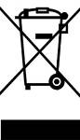
This marking indicates that this product should not be disposed with other household wastes throughout the EU. To prevent possible harm to the environment or human health from uncontrolled waste disposal, recycle it responsibly to promote the sustainable reuse of material resources. To return your used device, please use the return and collection systems or contact the retailer where the product was purchased. They can take this product for environmental safe recycling.

