Commercial Work Bench

Assembly Instructions

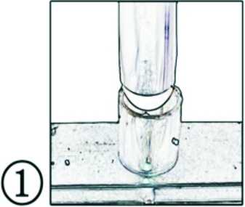
Let the tabletop upside down
on a soft clotin to prevent scratches.
Insert one pipe into a comer support.
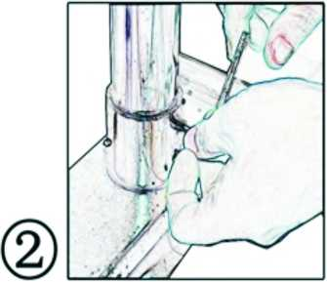
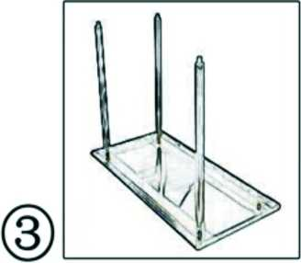
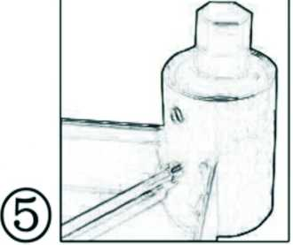
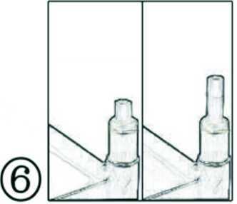
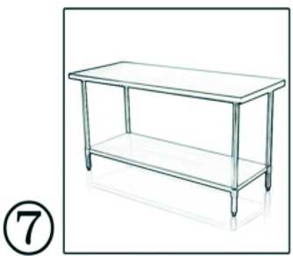

Remove the allen screws
and allen wrench.
Each corner support requires
Two allen screws.Wait until the
table is completely assembled
before securely tighening each allen screw.
After all four pipes have been
Attached,lower the adjustable
Table base and let each pipe
Into the base holes .
Each corner support requires
Two allen screws .Wait until the
table is completely assembled
before securely tightening each allen screw.
All four pipes can be adjusted for
The surfaces.that are not completely
level.Rotate the plasstic foot pad for
differences in floor surface.
Turn the table over after each screw
is securely tightened .Two people
should be required to rotate the table.
