Heat Press Heat Transfer Sublimation Machine
Ⅰ.Introduction
Hello, thank you for purchasing 10 "X12" (250x300mm) shake head heat press machine. Please read this manual carefully and store it in a safe place for future reference. If you need any help, please contact the seller directly by email
Ⅱ.The main dimensions of heat press machine：
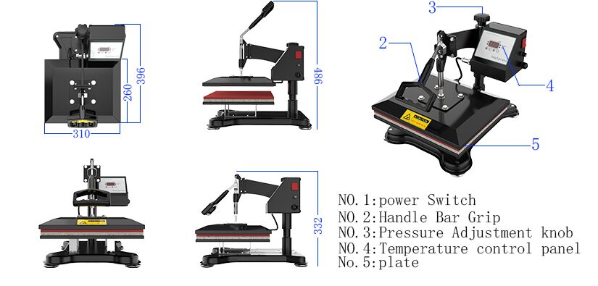

Ⅲ.Temperature control interface and detailed functions
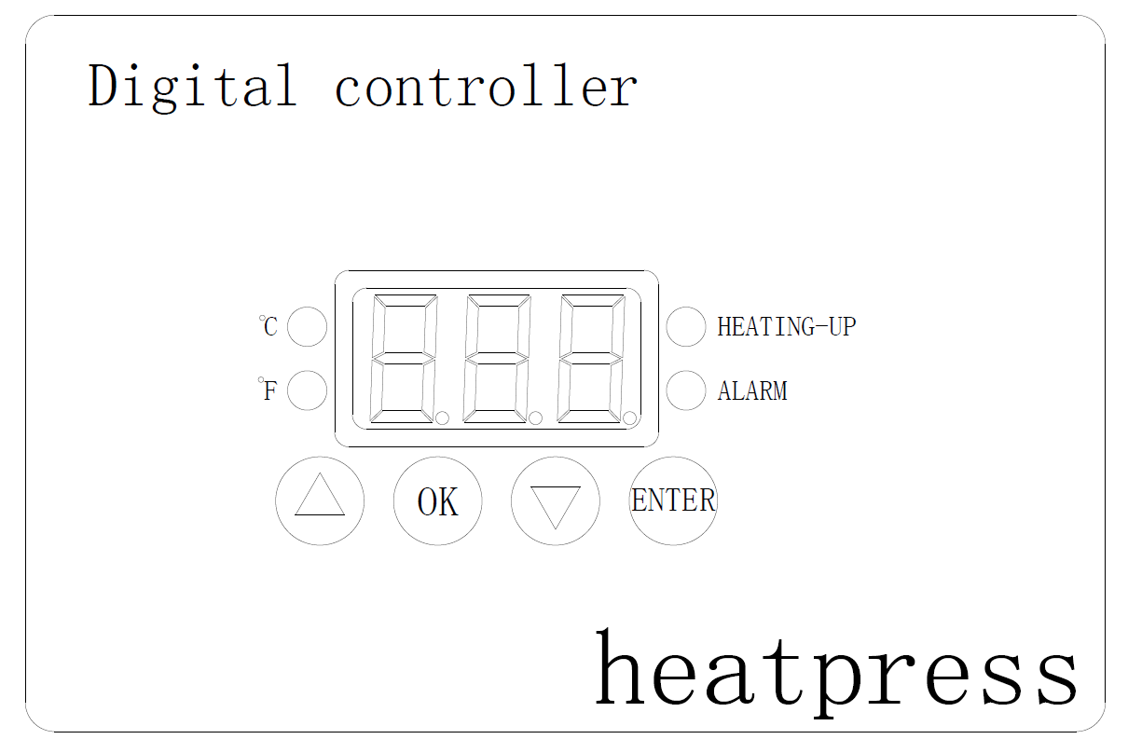
HEATING-UP: Temperature rise indicator--After the product is turned on, it continuously lights up during the heating process. When the temperature rises to a constant temperature, it lights up intermittently.
ALARM: Timing indicator--When the device starts timing, this indicator is on.
ENTER: Timing button--Press this key to start timing.
OK: Function selection and confirmation keys.
: Up or numeric key
: Scroll down or numeric key
℃ : Celsius indicator
℉ : Fahrenheit indicator

Ⅳ.Temperature time and Celsius Fahrenheit conversion setting method:

Ⅳ-1.Temperature setting
Press the “OK” key, and the screen will display “P-1”and immediately change to the last set temperature value.Then press the ▼ or ▲ key to adjust this value to the current required temperature. The maximum setting temperature is 250 ℃ or ℉. After setting, press the “OK” key to enter the time setting state.

Ⅳ-2. time setting
Complete the above, after entering the time setting state, the screen displays “P-2” and immediately changes to the last set time, and then press the ▼ or ▲ key to set the time value to the current required number, the maximum set value is 999 seconds. After setting, press the “OK”button again, the setting is completed, and the real-time temperature is displayed on the screen.

Ⅳ-3.Celsius Fahrenheit Conversion
In the power-on state, press and hold the "OK" key for 5 seconds, the screen displays “C” or “F”, press “▲” to display “F”, press “▼” to display “C”, “F”is Fahrenheit, “C ”is Celsius, then long press:“ OK ”key for 5 seconds to exit the setting state.

Ⅴ.Operating Steps
Ⅴ-1.Check whether the hot stamping board plug (see left in the figure below) has been reliably connected to the electrical control box connection socket.
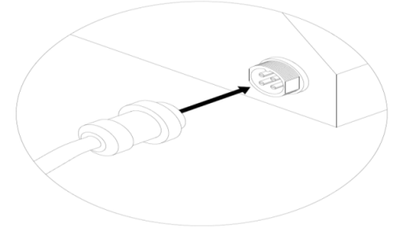 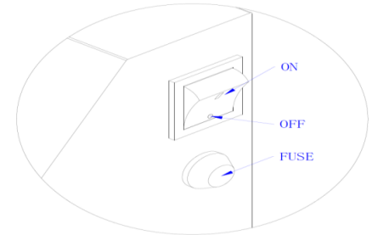 Ⅴ-2.Plug in the power and turn on the power switch “ON / OFF” (see the right of the figure above).
Ⅴ-3.(See the figure below) Lift the handle “2”, turn “3”, then repeatedly press or lift “2” and adjust “3”at the same time to obtain the most suitable pressure.
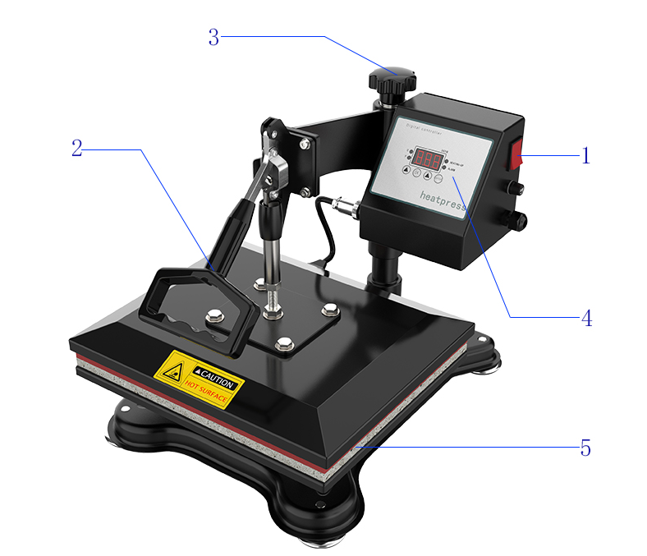
Ⅴ-4.Set the temperature and time according to “P-1” and “P-2”, and confirm whether the temperature unit is ℉ or ℃.
Ⅴ-5.After the temperature rises, lift the handle “2”, rotate the heating plate 90-180 degrees, then place the transfer T-shirt flat on “5”, and then place the thermal transfer pattern print side down on T Shirt, then turn the heating plate back to the original direction, press “2”, and then press the key on “4” to start the countdown. After the countdown, lift “2” to the other side and take out the T-shirt. The thermal transfer job is finished.

Ⅵ.Specifications
Voltage: 110 / 220V
Power: 650W
Frequency: 50-60HZ
Temperature adjustment range: 0-250 ° C or 0-482 ° F
Time control: 0-999 seconds
Machine weight: 24LBS
Package size: 18" x 16" x 15.5".

Ⅶ .Transfer temperature and time of various transfer materials
Ⅶ-1.Ceramic plate:
Tile temperature is set to 180-200 degrees, baking time is 180 seconds.
Hot stamping: wipe the surface of the tile with a flannel, apply the transfer to the front of the tile, and fix it with high-temperature tape, with the tile facing up, placed in the center of the foamed silicone board at the base, and press the pressure handle, such as excessive pressure Or too small, you can adjust the head height.
Ⅶ-2.Metal plate:
The temperature is set to 180-200 degrees and the baking time is 180 seconds
Hot stamping: Remove the film on the surface of the metal plate, attach the transfer paper to the front of the metal plate, and fix it with high-temperature tape, with the front side facing up, and place it in the center of the foamed silicone plate on the base. Too small, you can adjust the head height.
Ⅶ-3.Mug
The temperature is set to 180-200 degrees and the baking time is 180 seconds
Hot stamping: wipe the surface of the mug clean with a flannel, wrap the transfer paper around the mug, paste and fix it with high temperature tape, place it in the mold cavity of the baking machine, and push the pressure handle. If the pressure is too high or too small, you can adjust the stroke of the putter.
Ⅶ-4.Cloth art
- The temperature of ordinary cotton cloth or cloth with low cotton content is 180 ℃for 30 seconds.
- The temperature of scarves, chemical fiber and polyester is 130-140 degrees Celsius for 10 seconds.
- Cotton mouse pad temperature is 180℃ for 30 seconds, rubber mouse pad is 130℃ for 30 seconds.
- Dark T-shirts at 160℃ for 30 seconds.
- Light T-shirt at 180℃ for 30 seconds.
- Hot stamping: affix the transfer paper to the surface of the cloth to be ironed, and fix it with high-temperature tape, with the front side facing up, and place the transfer part in the middle of the foamed silicone board on the base. Press the pressure handle, such as too much or too little pressure , Can adjust the height of the machine head. After the temperature rises to the initial temperature, press down the pressure handle, press the “ENTER” key, and release the pressure handle immediately after the timer is over.
- The above temperature and time are reference values. The actual hot stamping process will be slightly biased by the indoor ambient temperature and the thickness of the hot stamping material, which is mainly based on user experience.

Ⅷ.Troubleshooting
I-1. The color is too light: the temperature is too low or the pressure is uneven or the time is too short.
I-2. The pattern is blurred: it takes too long to cause the ink to spread.
I-3. The surface of the pattern is dull: the pressure is too high or the temperature is too high.
I-4. The pattern is partially blurred: the heat distribution in the hot and fierce areas is uneven.
I-5. The pattern is scarred: the stamping time is too long.
The color of I-6 pattern is different: uneven pressure or uneven transfer coating.
I-7. Adhesive paper: The temperature is too high or the object's transfer coating is poor.

